Acknowledgement

|  |
| --- |
|  |
|  |
|  |

* The success and final outcome of this project required a lot of guidance and assistance from many people and I am extremely privileged to have got this all along the completion of my project. All that I have done is only due to such supervision and assistance and I would not forget to thank them.
* I am thankful to and fortunate enough to get constant encouragement, support and guidance from all Teaching staffs of L J BCA which helped us in successfully completing our project work. Also, I would like to extend our sincere esteems to all staff for their timely support
* I owe my deep gratitude to our project guide Mr. Vikas Gokhale Sir, who took keen interest on our project work and guided us all along, till the completion of our project work by providing all the necessary information for developing a good system.

Index

1. Project Profile 5
2. Company Profile 6
3. Tools And Technology Used 7
4. Hardware And Software Requirements 8
5. Screen Layouts
   1. Landing Page (Home) 10
   2. Pricing Page 12
   3. About Us Page 14
   4. Tools Page 17
   5. Study Page 19
   6. Contact Page 21
   7. Login Page 22
   8. SignUp Page 23
   9. Profile Page After Login 24
      1. Change Pasword Tab 25
      2. Edit Profile Tab 26
      3. Upload Tab Only For Hackers 27
      4. Logout Tab 28
   10. Admin Login (Page) 29
       1. Profile Page 30
       2. Registration details (Page) 30
       3. Course Details (Page) 31
       4. Query Form (Page) 31
6. Report Layouts 32
   1. Login Page (User/Hacker) 33
      1. Not Empty validation 33
      2. Invalid Username & Password 33

Index

* 1. Login Page (Admin Panel) 34
     1. Not Empty Validation 34
  2. Registration Page (User/Hacker) 35
     1. Not Empty Validation 35
     2. Valid Email Validation 35
     3. Valid Number Validation 36
     4. Valid Date Validation 36
  3. After Login Effects(User/Hacker) 37
     1. Profile Chip 37
     2. Not Empty Field Validation 37
     3. Password Changing 38
        1. Confirm Password Not Matched 38
     4. Edit Profile 38
     5. Course Upload 40
  4. After Login Effects(Admin Panel) 41
     1. Profile Update And View 41
        1. Showing Details From DB 41
        2. Registration Details Report 41
        3. Course Uploaded Report 42
        4. Query Form Uploaded Report 42
        5. Take Location Of Users Report 43
        6. Tracking location of users 43
        7. Register New Admin From Main 44

1. Data Dictionary 45
   1. Adminmaster 45
   2. Course 46
   3. Query_Form 47
   4. Registration 48

Index

* 1. Trackingg 49

1. Conclusion 50
2. Bibliography 51

Project Profile

|  |
| --- |
|  |
|  |
|  |

* The City Of Hackers (TCOH) system is the system in which user can learn about hacking from our best professional Hackers and they provide tools and materials which are used in hacking.
* TCOH gives facility to give knowledge and teach about the ethical hacking like white hat and also teach to secure computers, servers and websites from black hat hackers and viruses.
* In this system when a new visitors comes then they see the basic demo articles, demo videos and also packages details on our system and also they can read the feedback and they can register to our system.
* In this system when user comes so first he/she needs to do login and after login they can get access to their account. After the access they can upload/update their profile, they can watch courses from their selected package.
  + After course the user can study, watch tutorial, or live and through this they can learn hacking.
  + After course the user can study, watch tutorial, or live and through this they can learn hacking.
  + After the completion of course the expert give assignment and after user submit and passes in assignment then our system publish certificate of hacking.

Company Profile

|  |
| --- |
|  |
|  |
|  |

* + - 1. Organization’s Name : Aks Industries
      2. Addresh : Aks Industries, To.Po.Pirana,Ta.Daskroi, Dist Ahmedabad-382425
      3. Email Id:- aksindustries1@gmail.com
      4. Contact No : +917778899125
      5. Remarkable Details : Filter Based Company

Tools and Technology Used



* **Front – End:**
  + PHP 7.1.11

* **Back – End:**
  + MySQL 5.7.20

* **Scripting:**
  + HTML5, CSS, Bootstrap, JavaScript

* **Web Server:**
  + Wamp Server



Hardware And Software Requirements

2.1 Hardware Requirements

|  |  |  |
| --- | --- | --- |
| **Processor** | **:** | Pantium 4 or Higher |
| **Memory** | **:** | 512 Mb or Higher |
| **Hard disk** | **:** | 1 GB |
| **Monitor** | **:** | 15’ Color Monitor |
| **Key Board** | **:** | Standard Windows Keyboard |
| **Mouse** | **:** | Standard Windows Mouse |

2.2 Software Requirements

|  |  |  |
| --- | --- | --- |
| **Operating System** | **:** | Windows XP or Higher |
| **Front End** | **:** | Php 7.1 + (Hypertext Preprocessor) |
| **Back End** | **:** | MySql |
| **Design Tools** | **:** | Adobe PhotoShop and Filmora |

Screen Layouts

Landing Page(Home)

|  |
| --- |
|  |
|  |
|  |

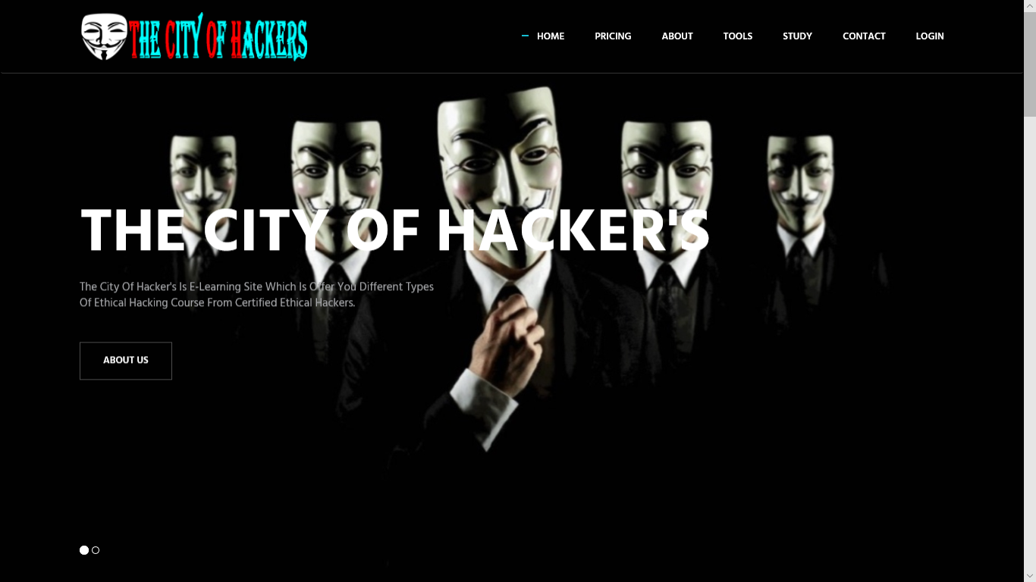

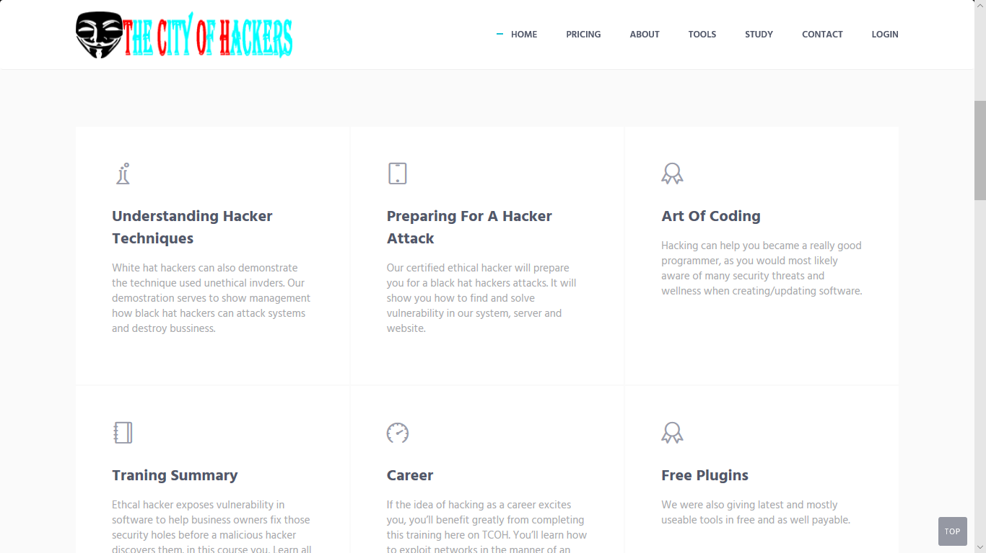

Landing Page(Home)

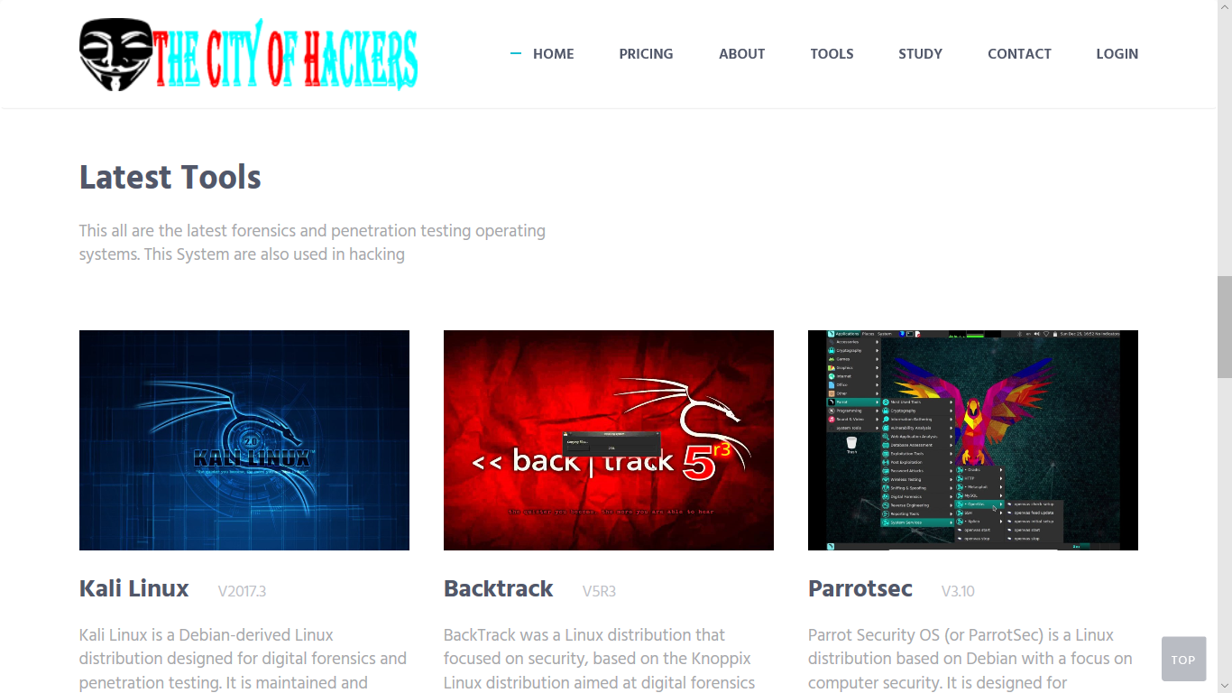

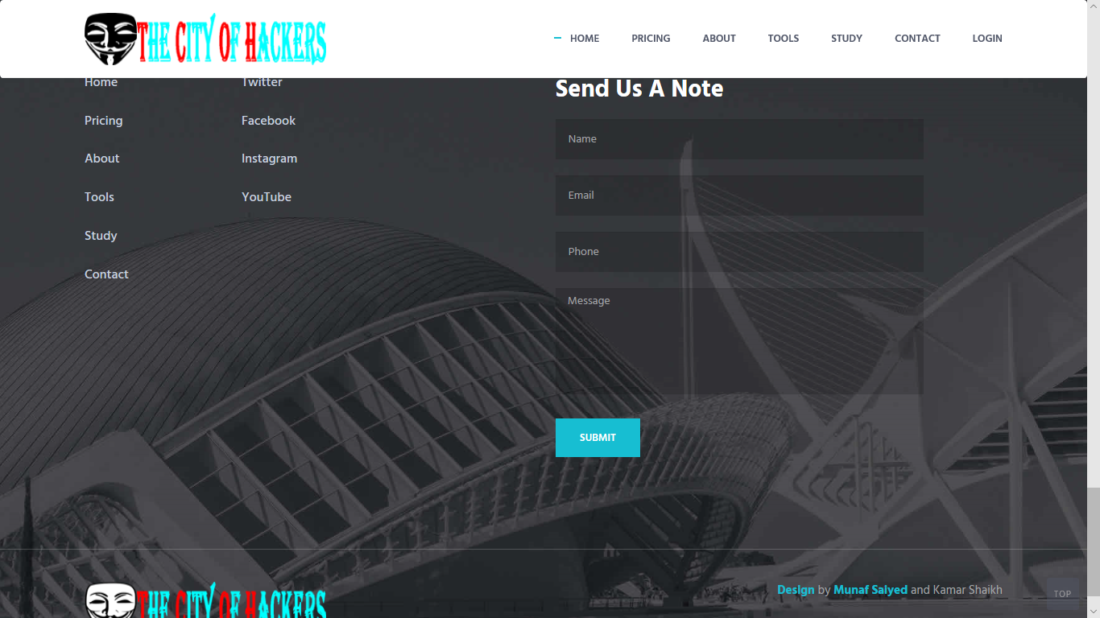

|  |
| --- |
|  |
|  |
|  |

Pricing Page

|  |
| --- |
|  |
|  |
|  |



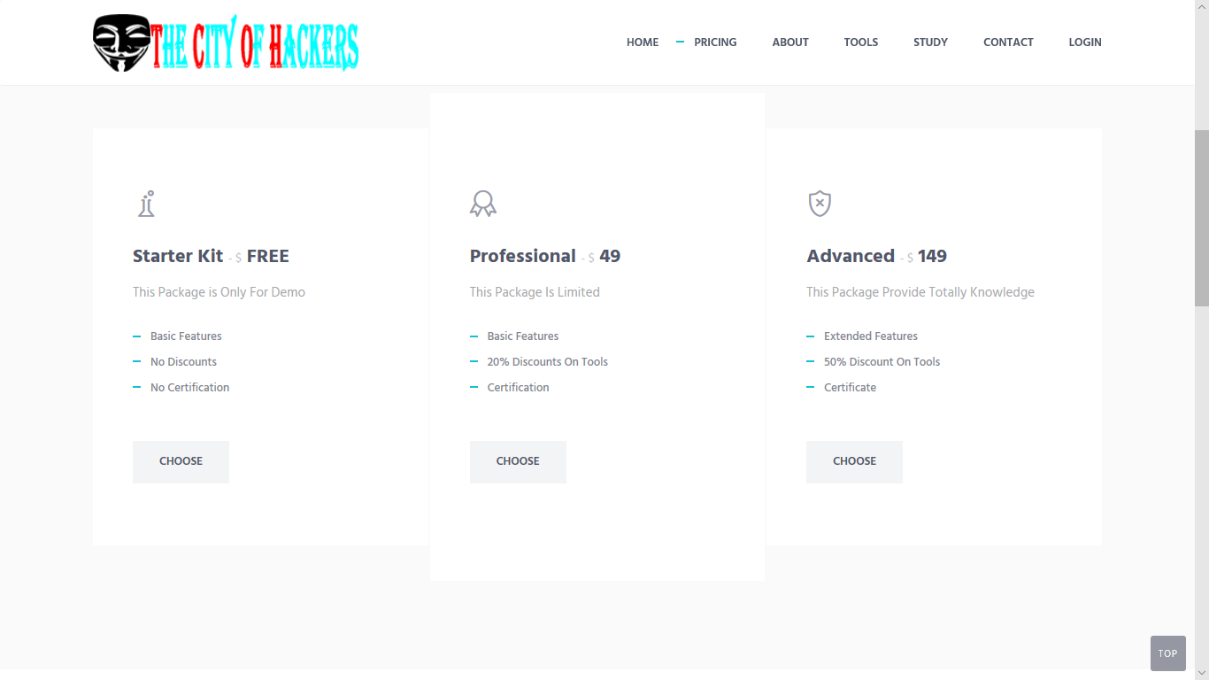

|  |
| --- |
|  |
|  |
|  |

Pricing Page

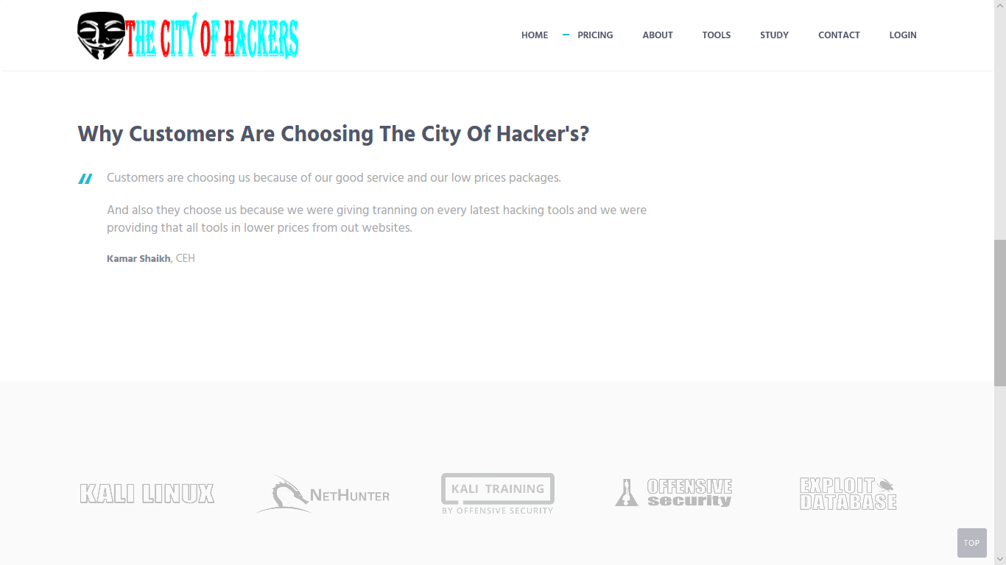

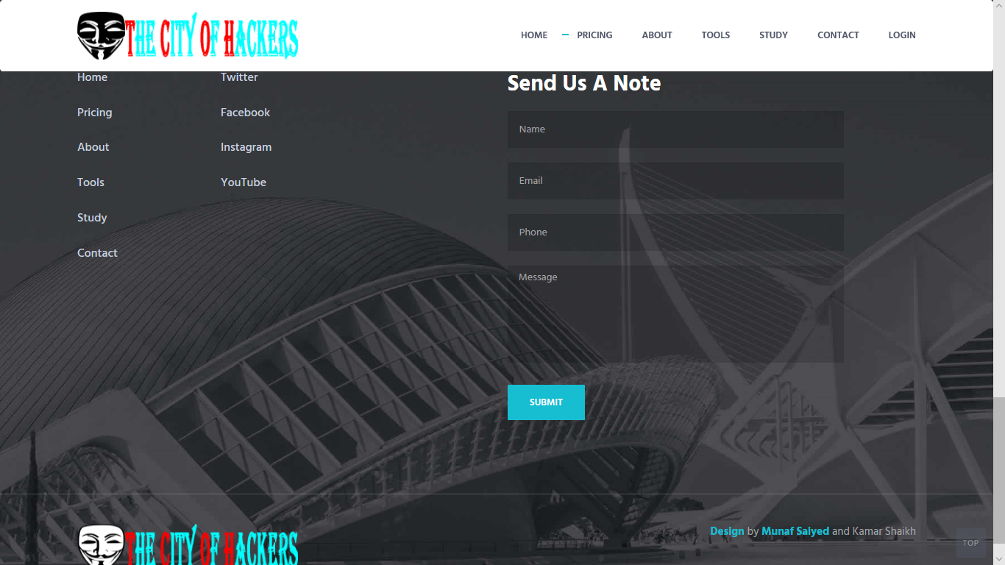

|  |
| --- |
|  |
|  |
|  |

About Us (Page)

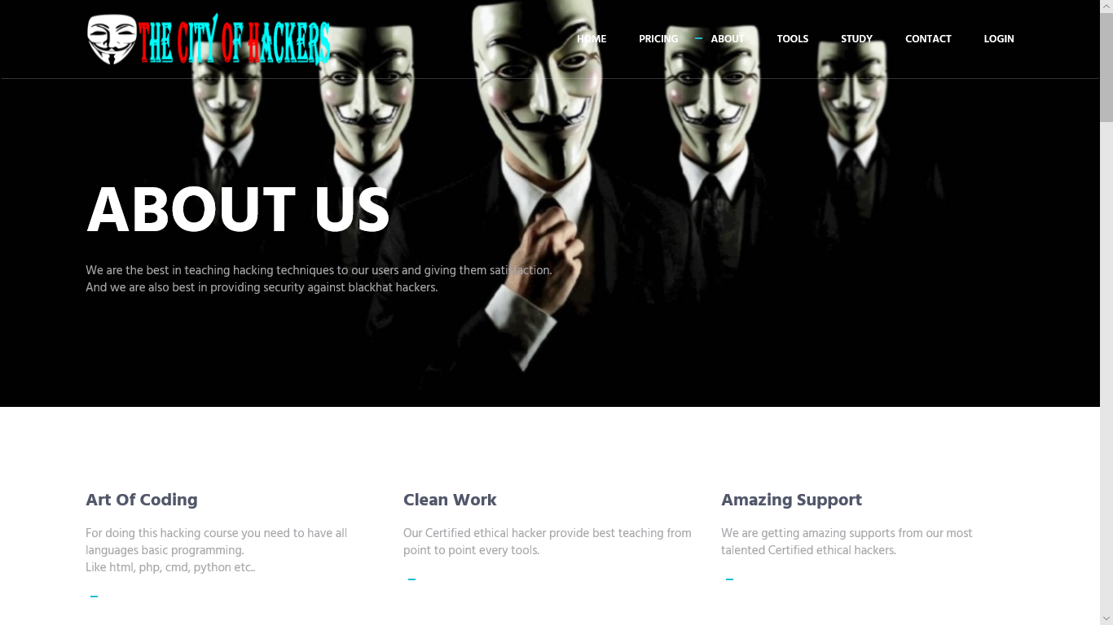

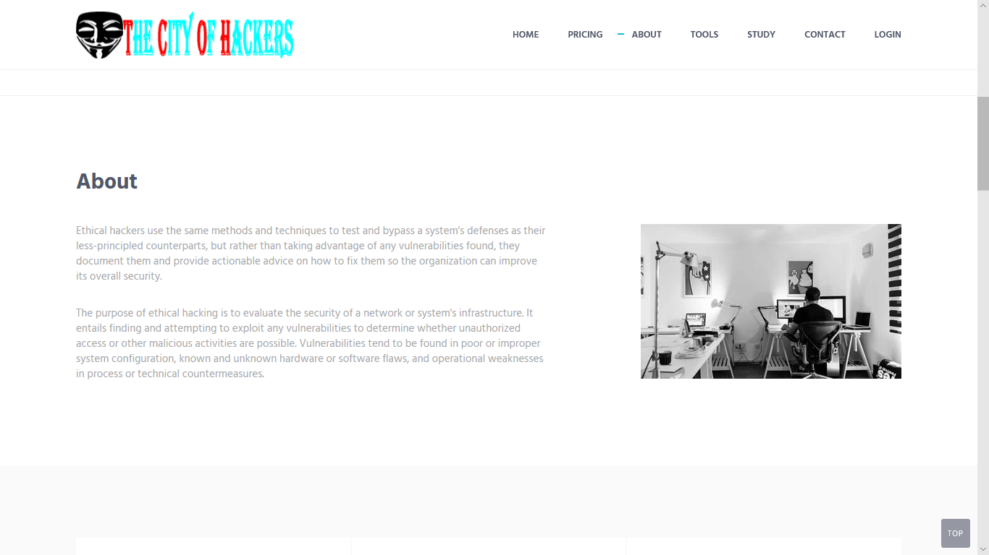

|  |
| --- |
|  |
|  |
|  |

About Us (Page)

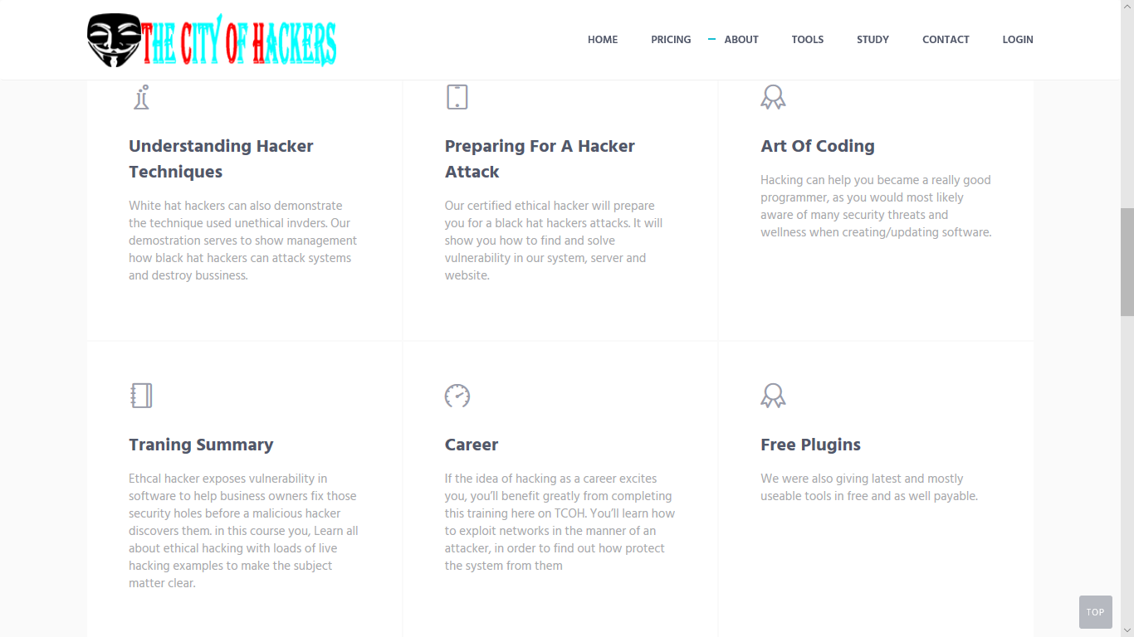

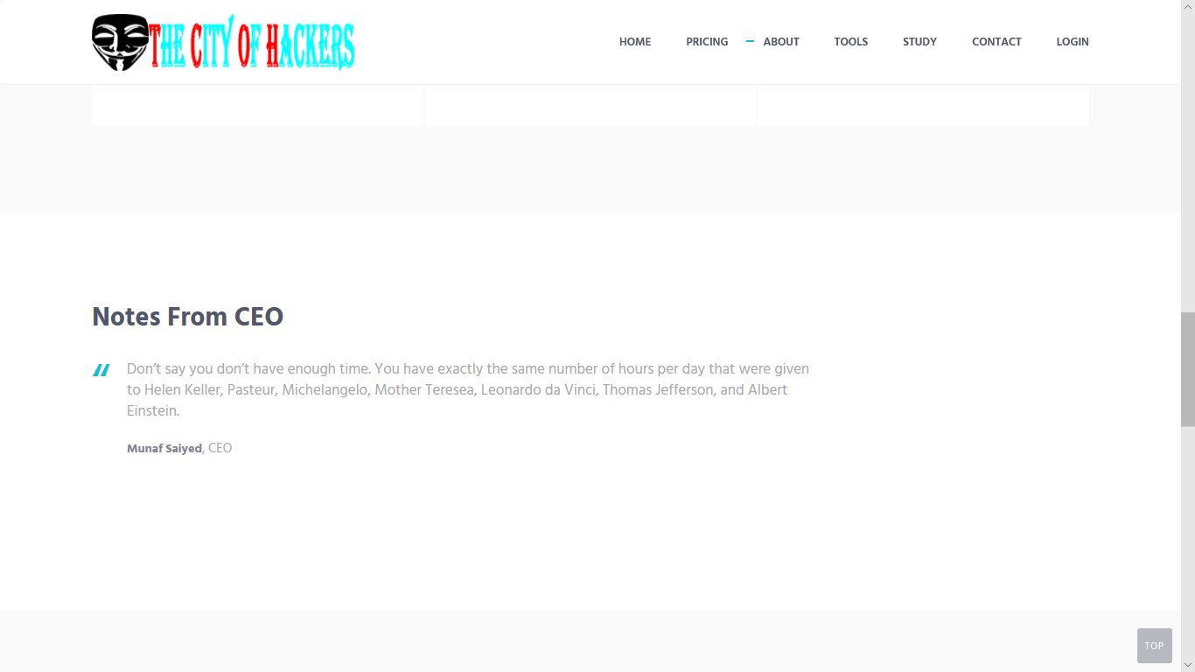

About Us (Page)

|  |
| --- |
|  |
|  |
|  |

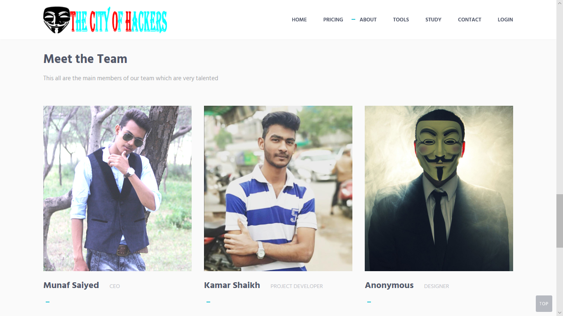

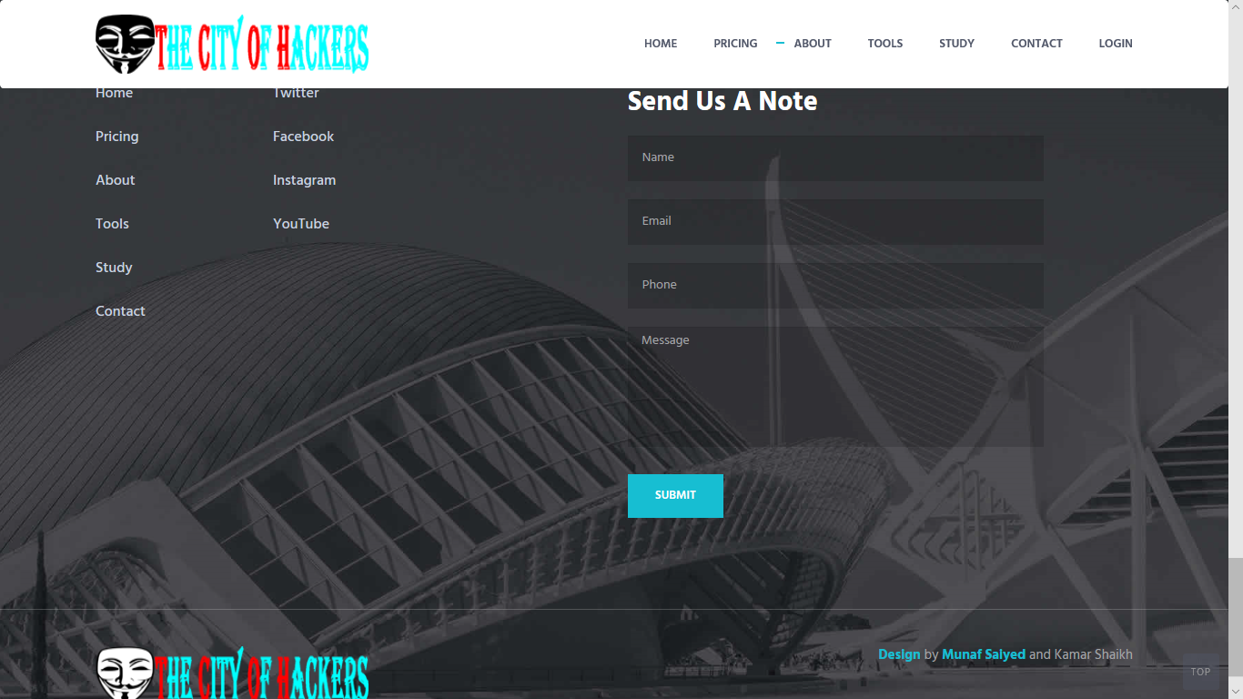

Tools (Page)

|  |
| --- |
|  |
|  |
|  |

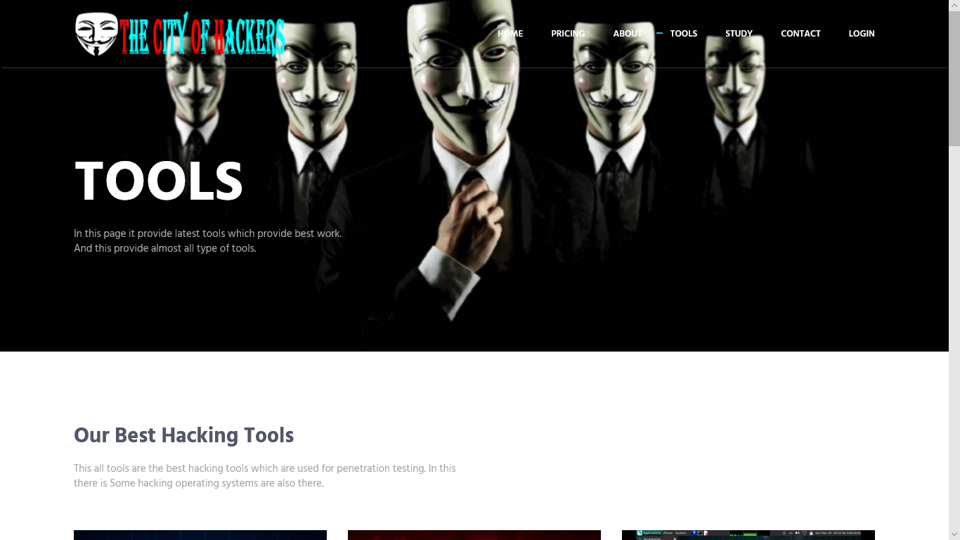

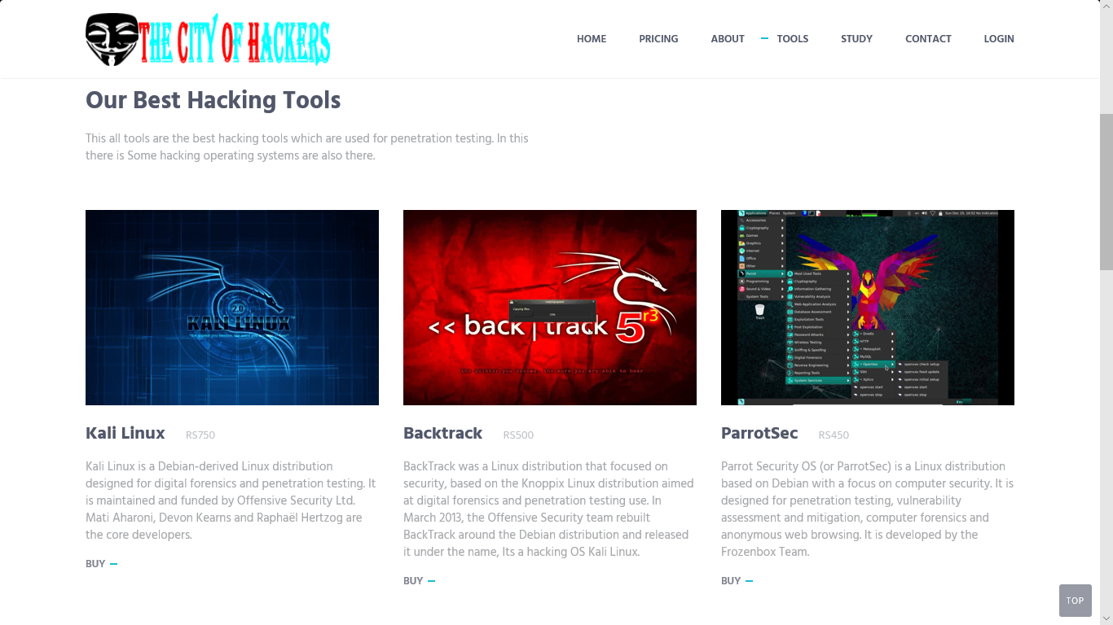

Tools (Page)

|  |
| --- |
|  |
|  |
|  |

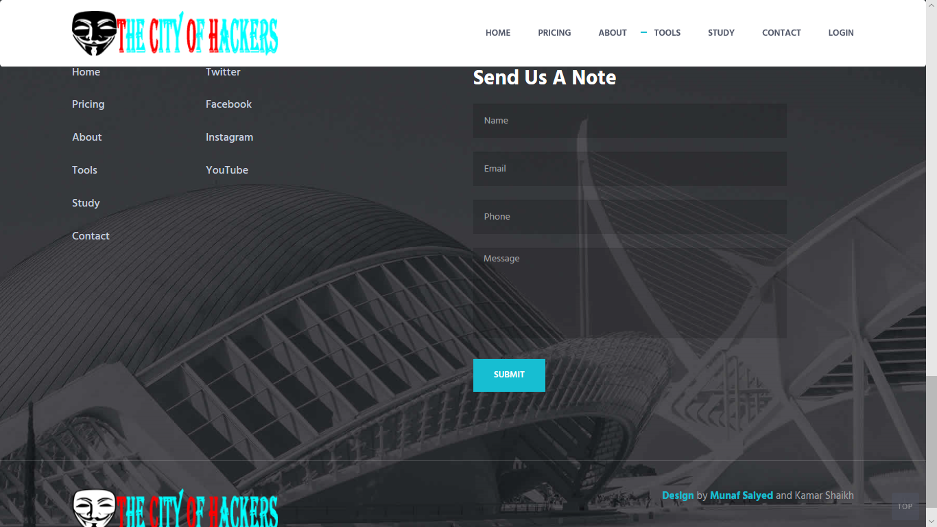

Study (Page)

|  |
| --- |
|  |
|  |
|  |

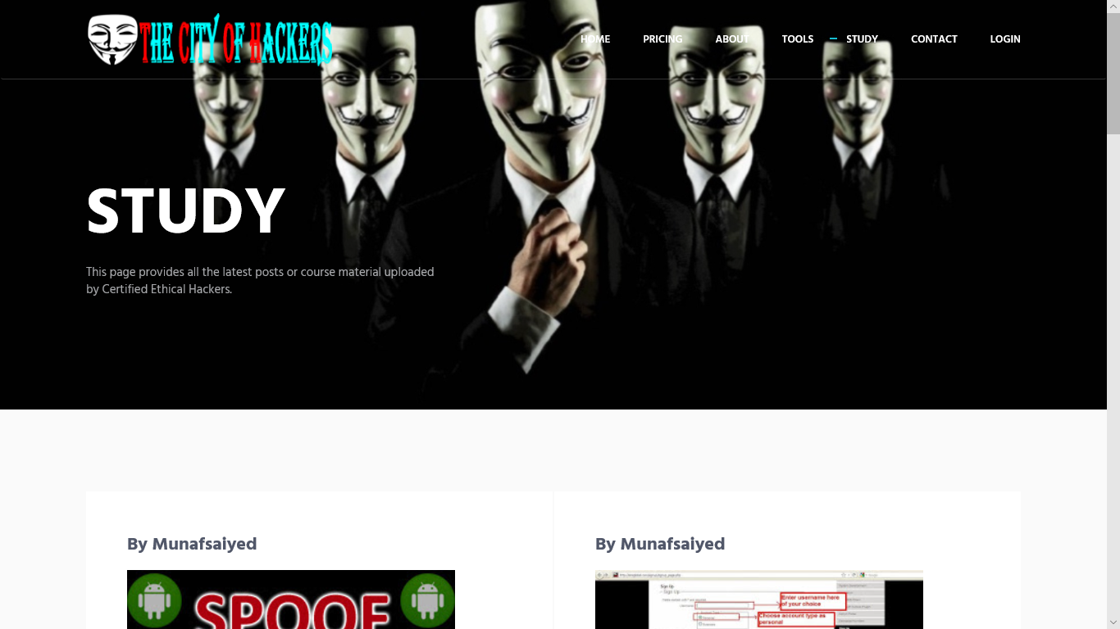

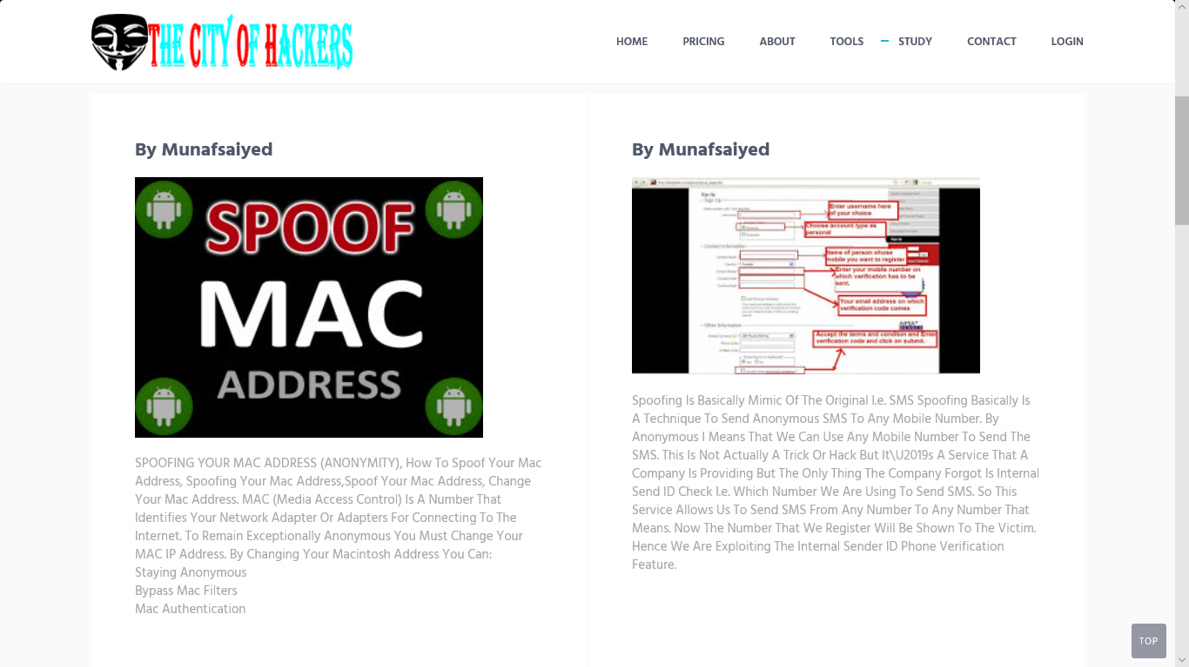

Study (Page)

|  |
| --- |
|  |
|  |
|  |

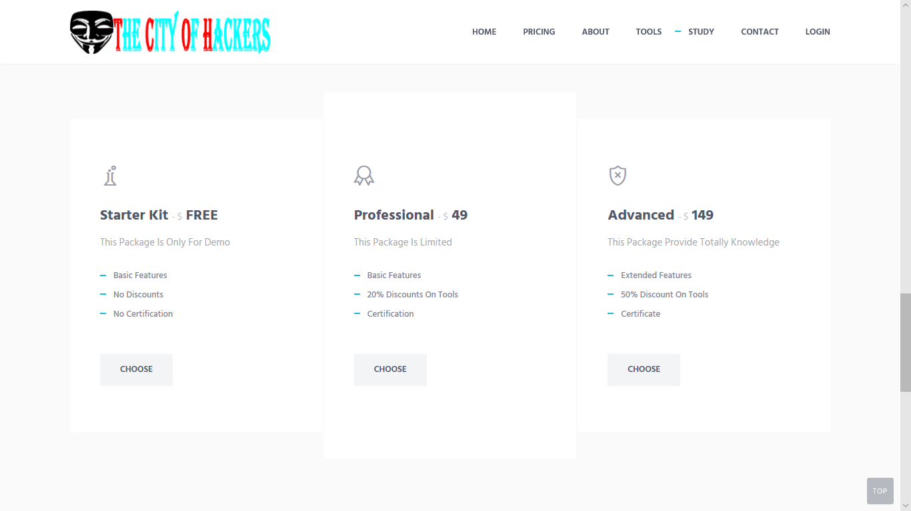

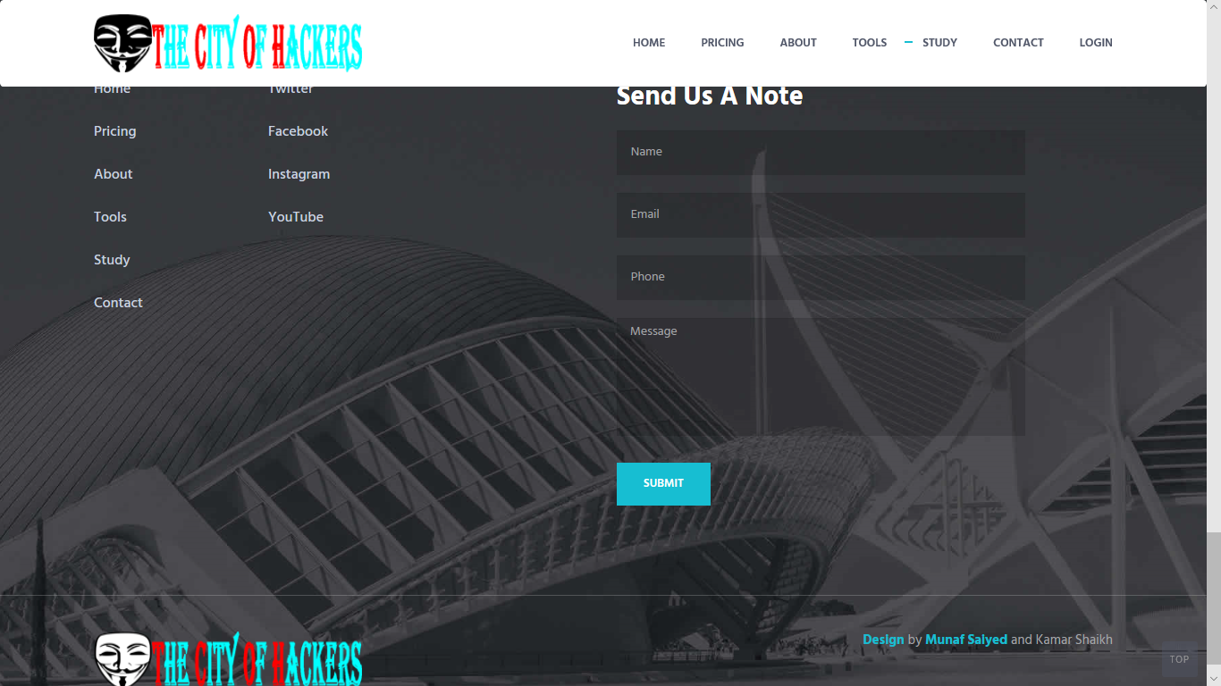

Contact (Page)

|  |
| --- |
|  |
|  |
|  |

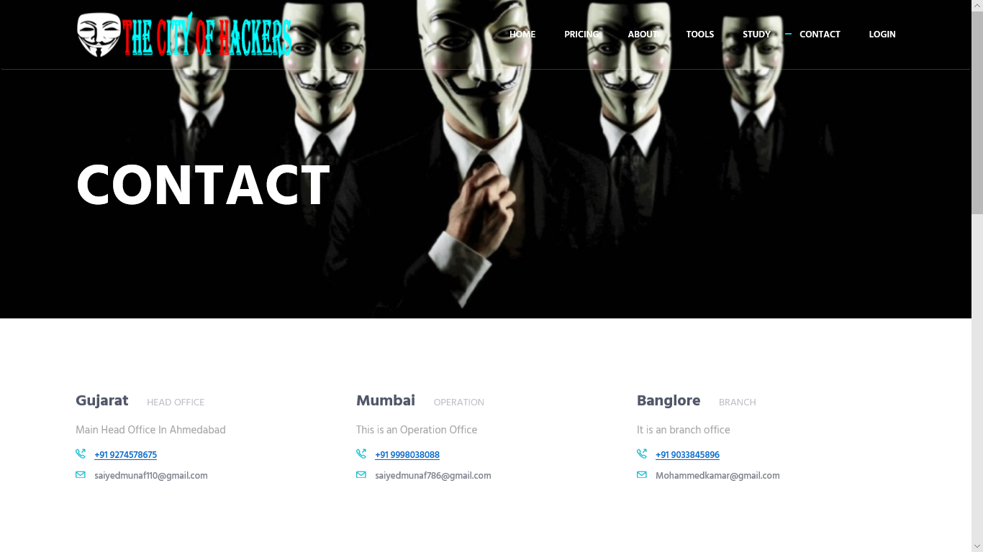

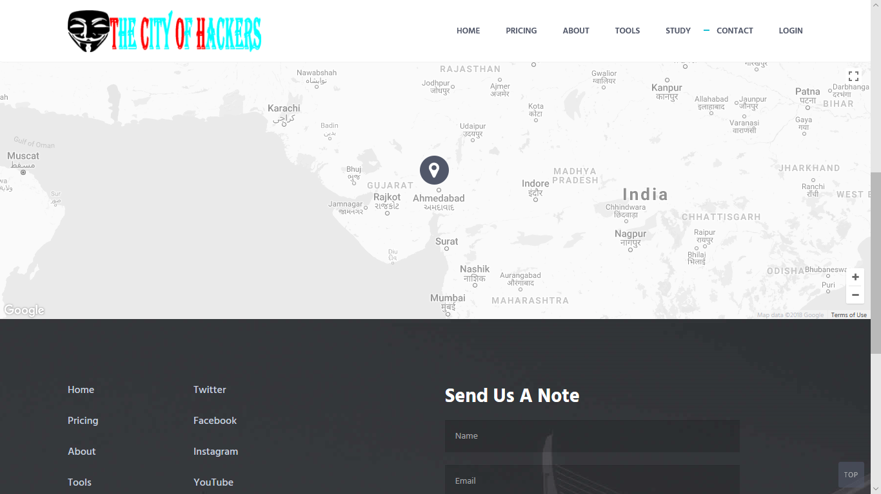

Login (Page)

|  |
| --- |
|  |
|  |
|  |

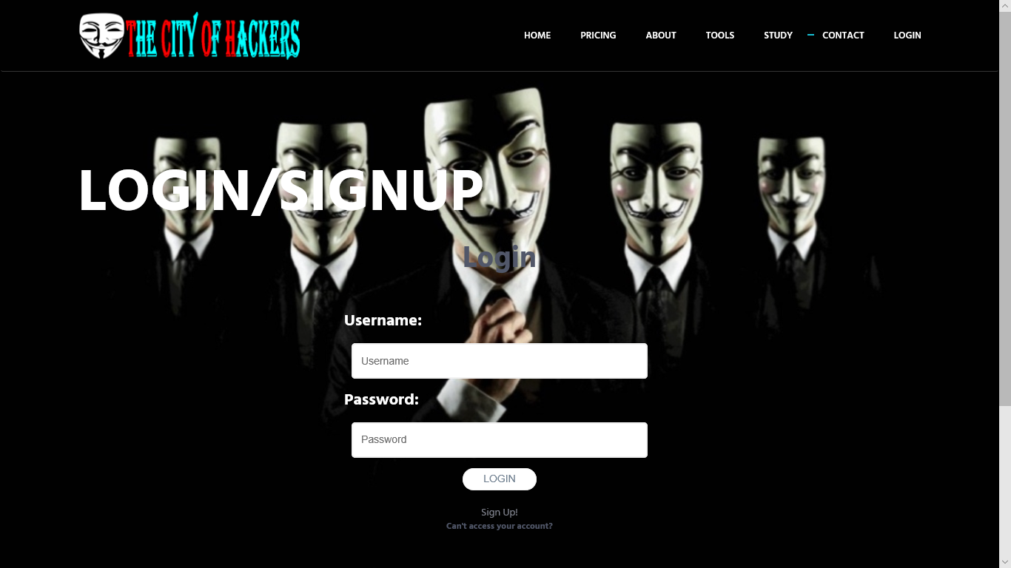

SignUp (Page)

|  |
| --- |
|  |
|  |
|  |

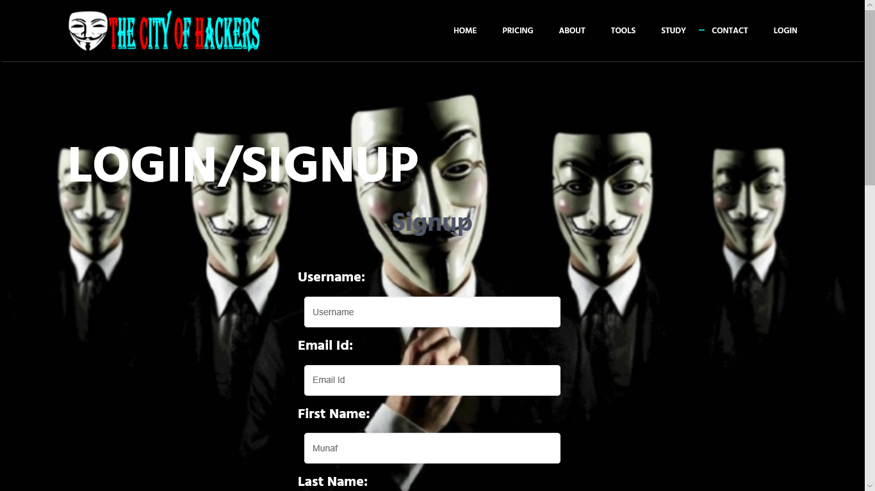

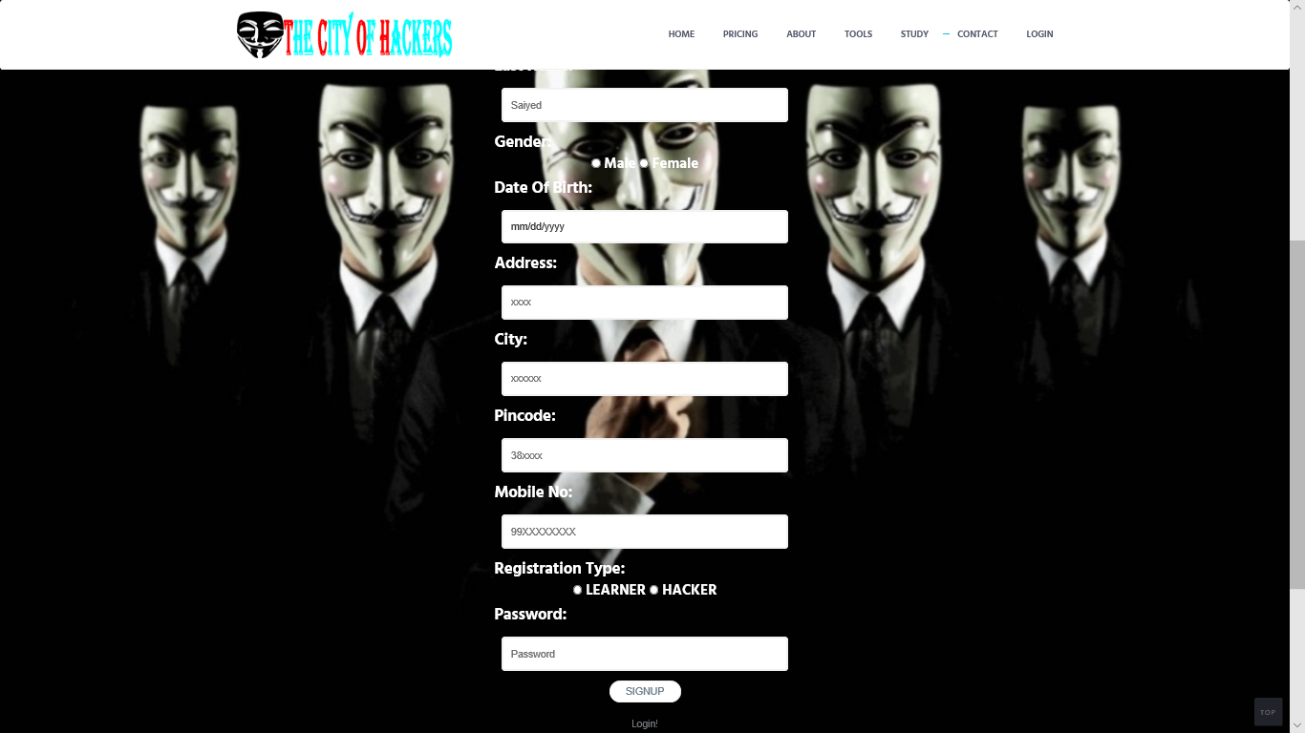

Profile (Page) After Login

|  |
| --- |
|  |
|  |
|  |

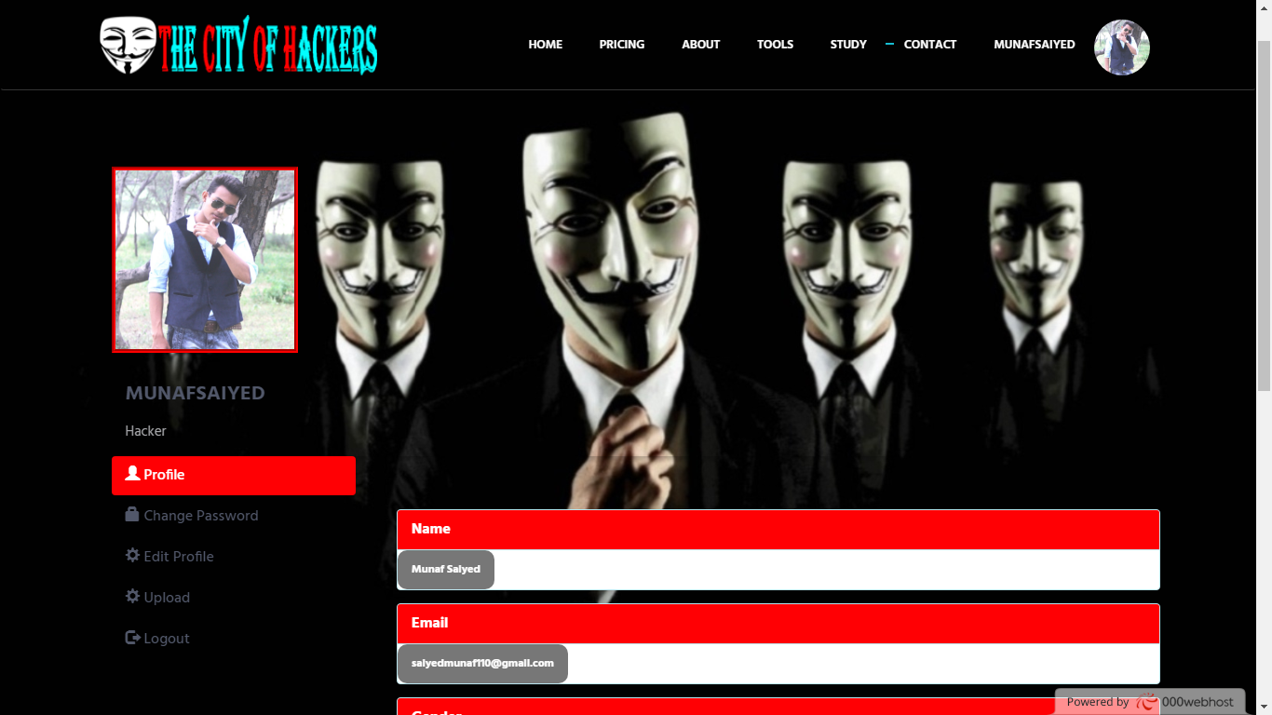

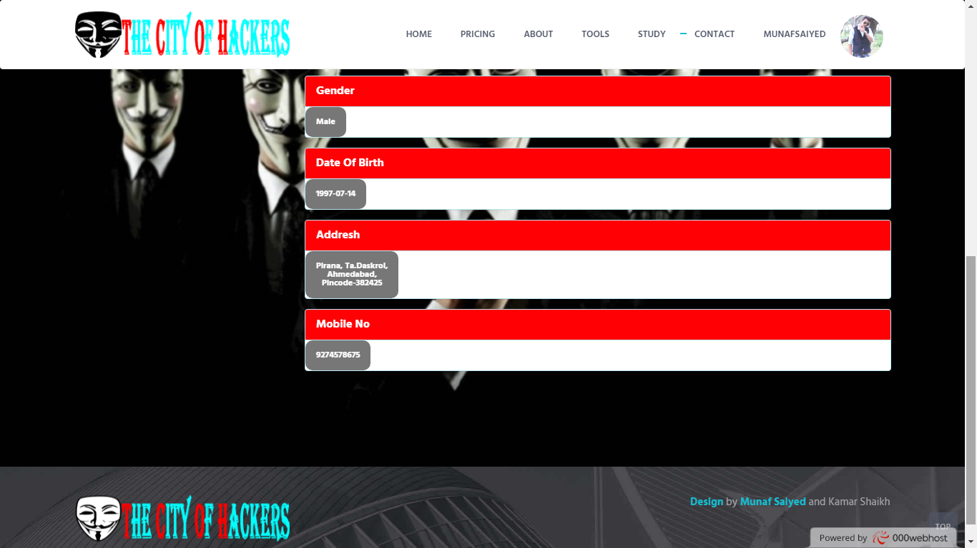

Profile (Page) After Login

|  |
| --- |
|  |
|  |
|  |

*Change Password Tab:*

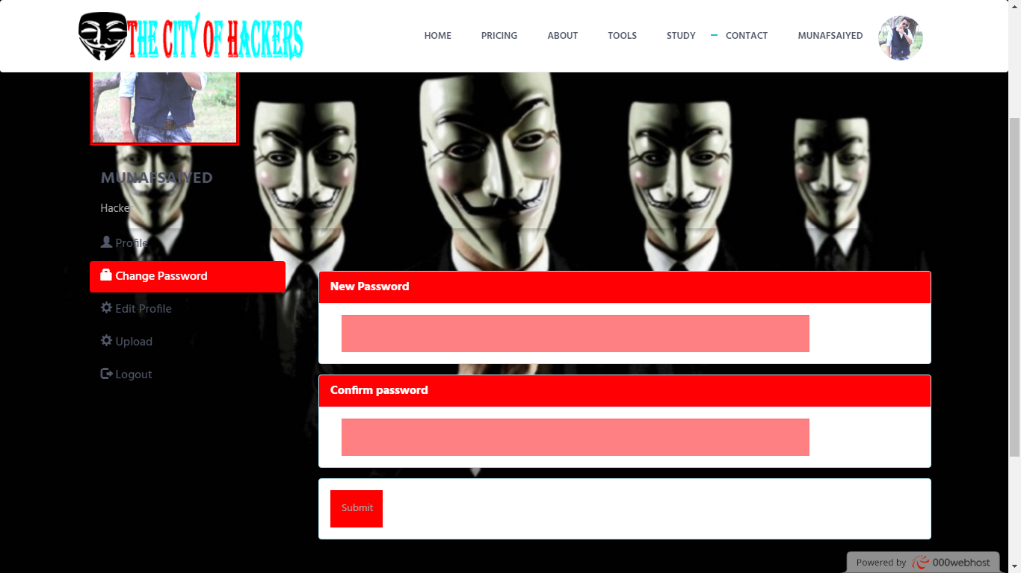

|  |
| --- |
|  |
|  |
|  |

Profile (Page) After Login

|  |
| --- |
|  |
|  |
|  |

*Edit Profile Tab:*

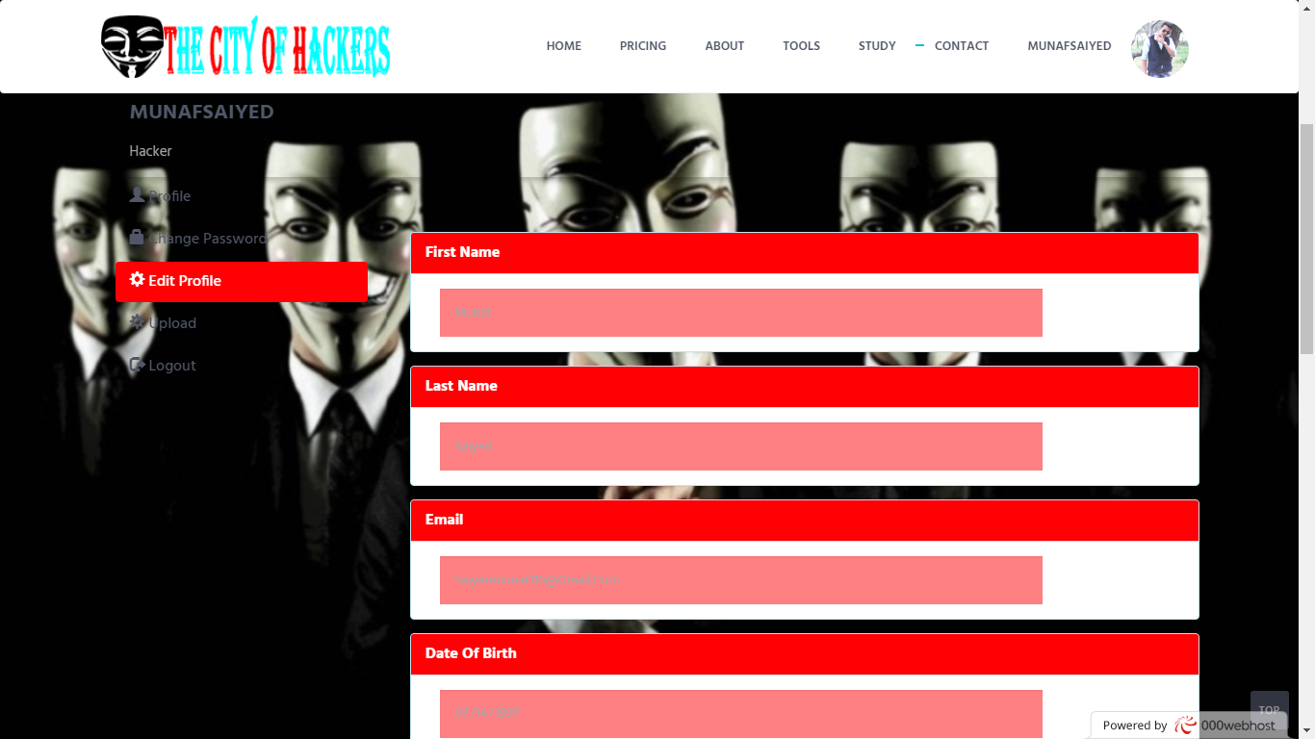

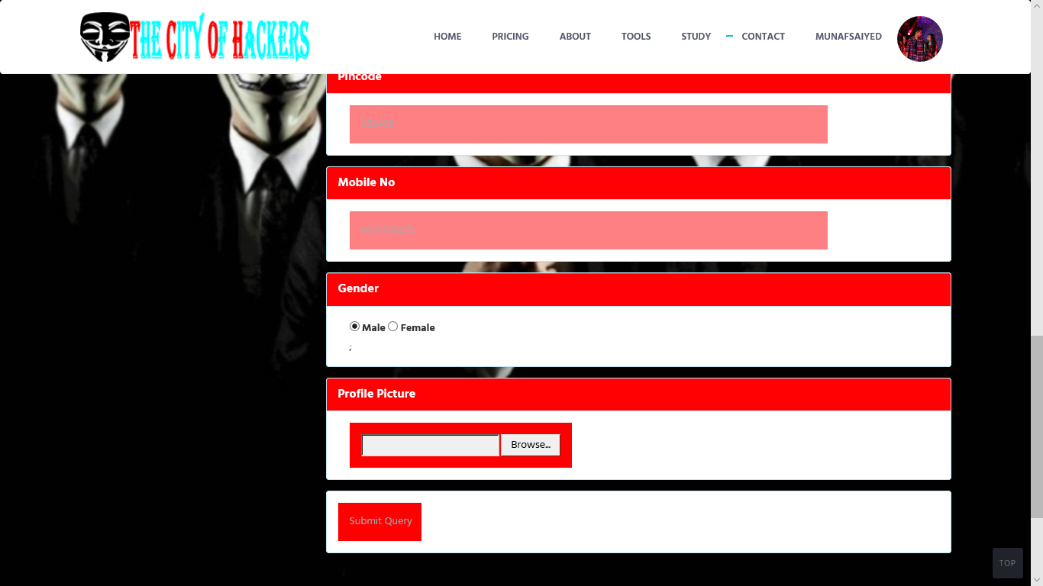

|  |
| --- |
|  |
|  |
|  |

Profile (Page) After Login

|  |
| --- |
|  |
|  |
|  |

*Upload Tab Only For Hackers Login:*

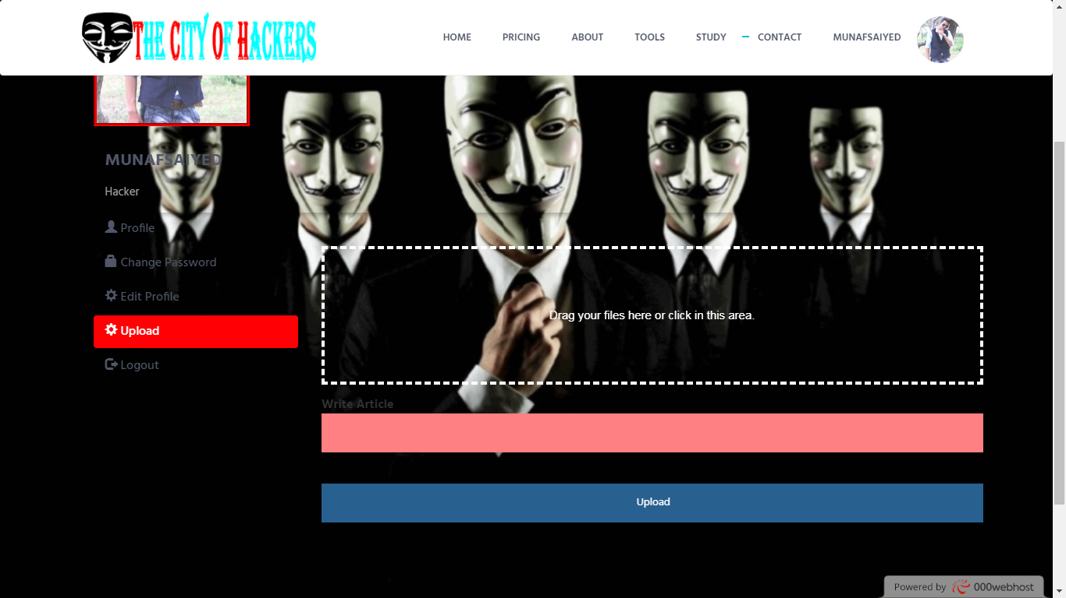

Profile (Page) After Login

|  |
| --- |
|  |
|  |
|  |

*Logout Tab:*

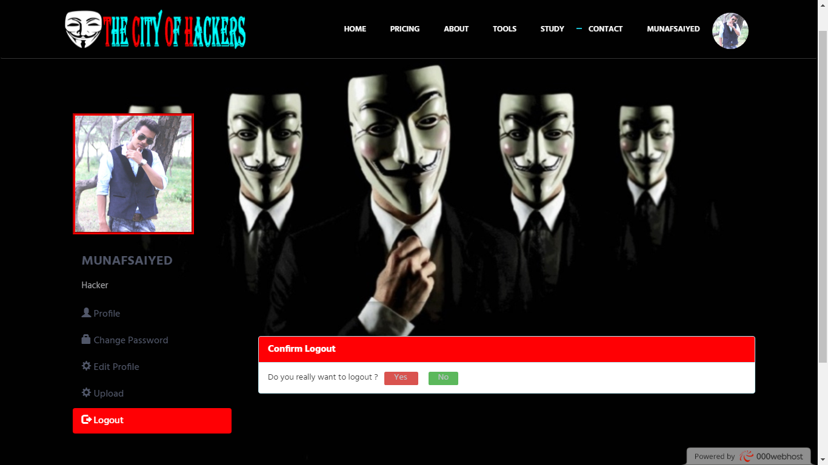

|  |
| --- |
|  |
|  |
|  |

|  |
| --- |
|  |
|  |
|  |

Admin Login (Page)

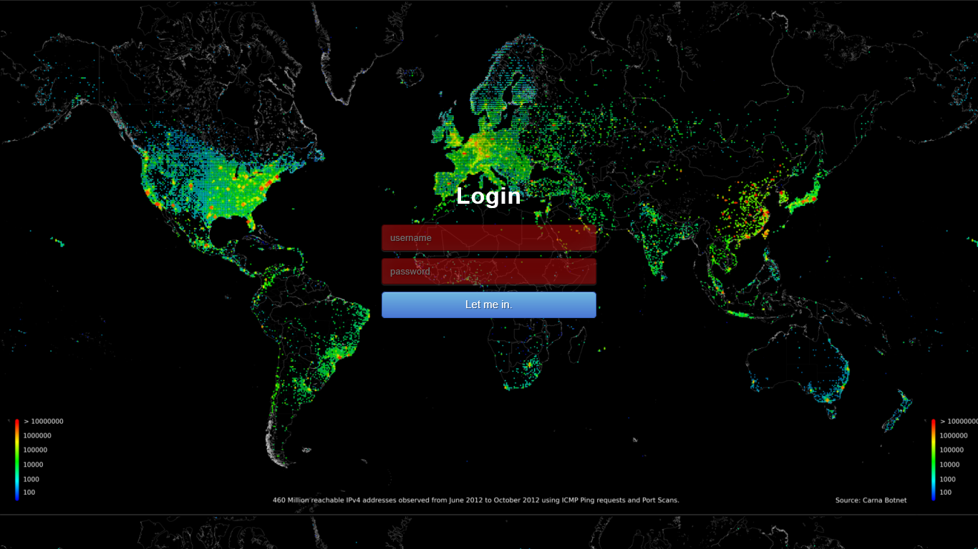

|  |
| --- |
|  |
|  |
|  |

Admin Login (Page)

*Profile Page:*

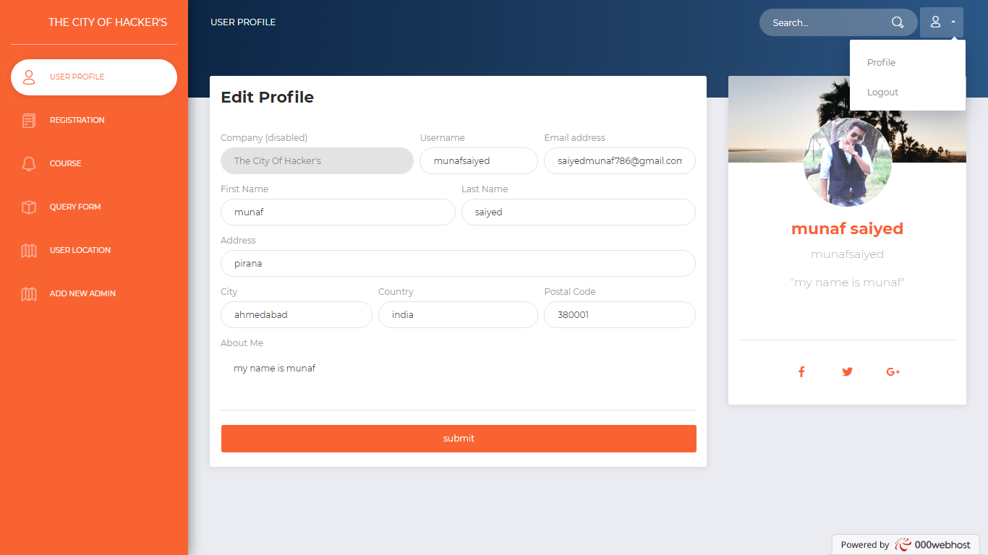

*Registration details (Page):*

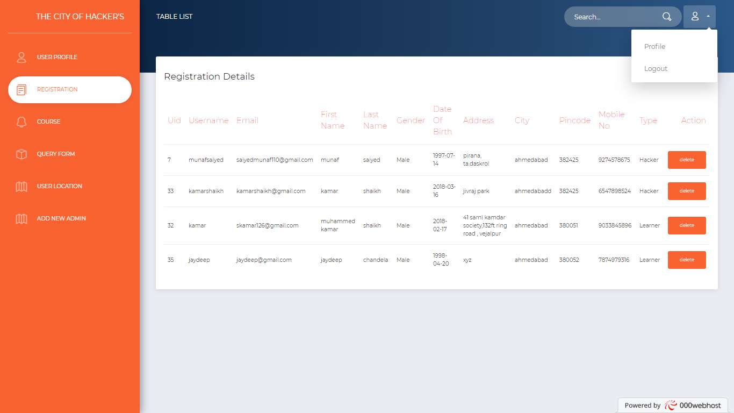

Admin Login (Page)

*Course Details (Page):*

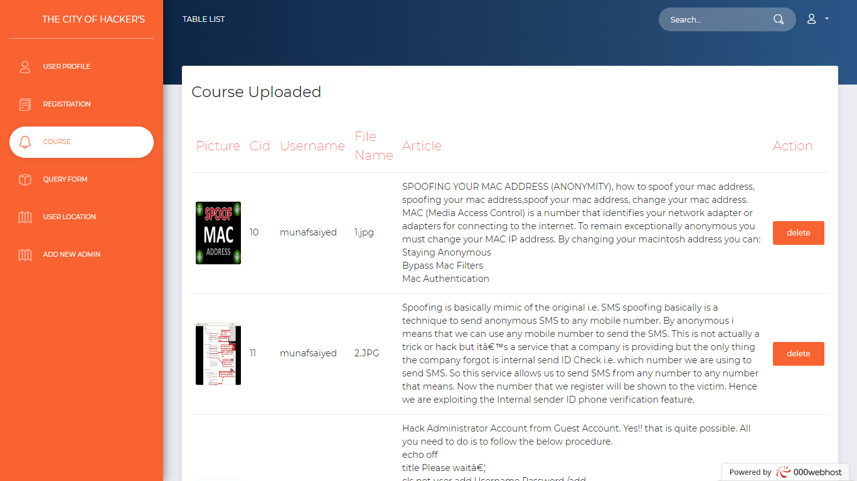

*Query Form (Page):*

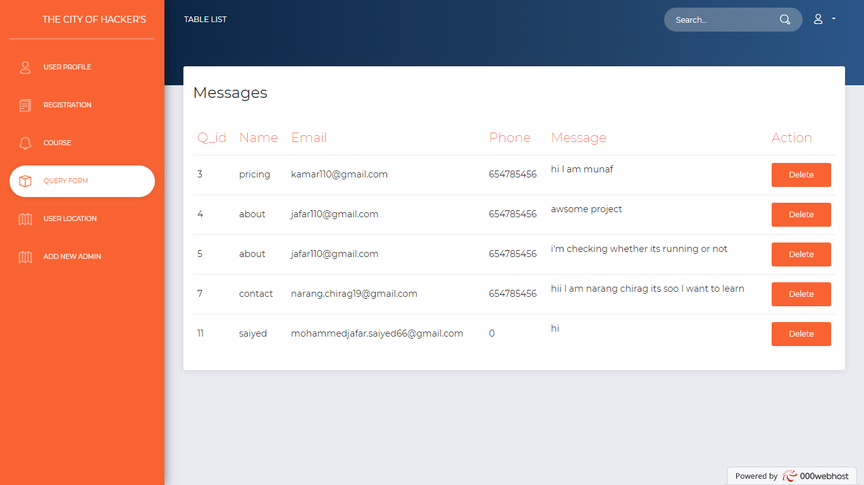

|  |
| --- |
|  |
|  |
|  |

TCOH

The City Of Hacker’s

Report Layouts

|  |
| --- |
|  |
|  |
|  |

Login Page (User/Hacker)

*Not Empty Validation:*

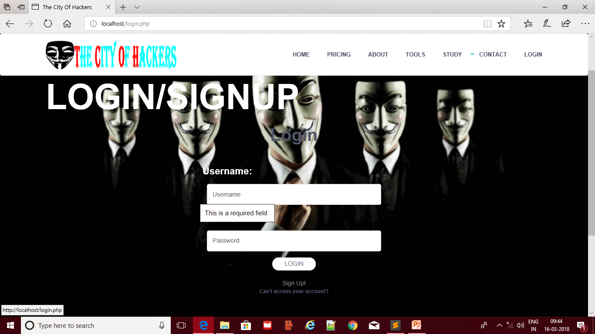

*Invalid Username &Password:*

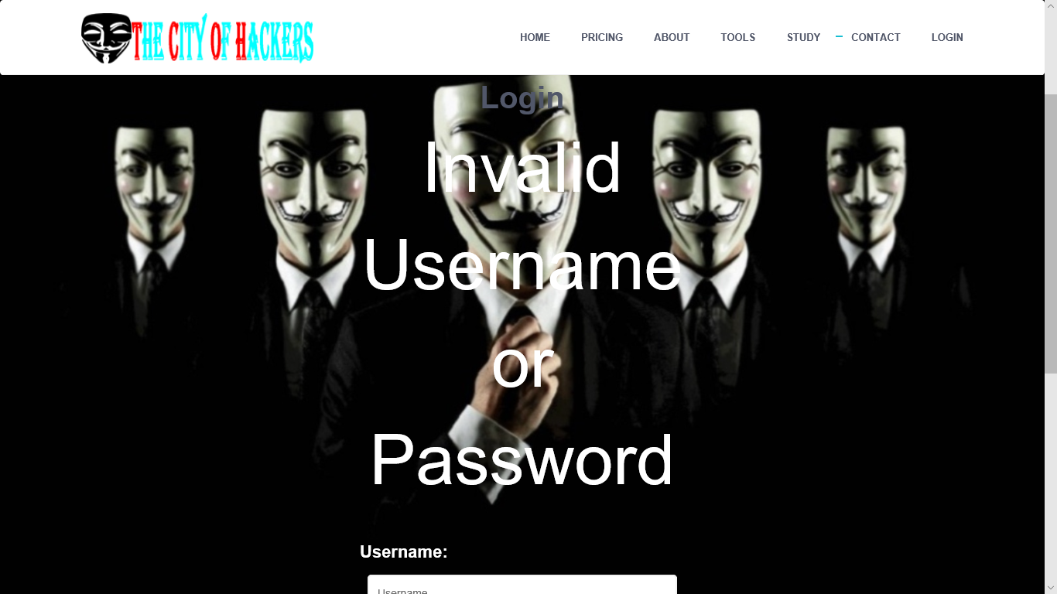

|  |
| --- |
|  |
|  |
|  |

Login Page (Admin Panel)

*Not Empty Validation:*

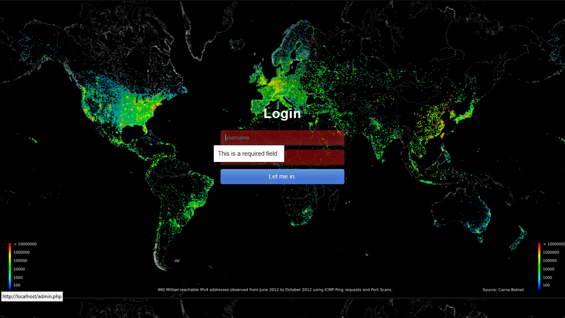

|  |
| --- |
|  |
|  |
|  |

Registration Page (User/Hacker)

*Not Empty Validation:*

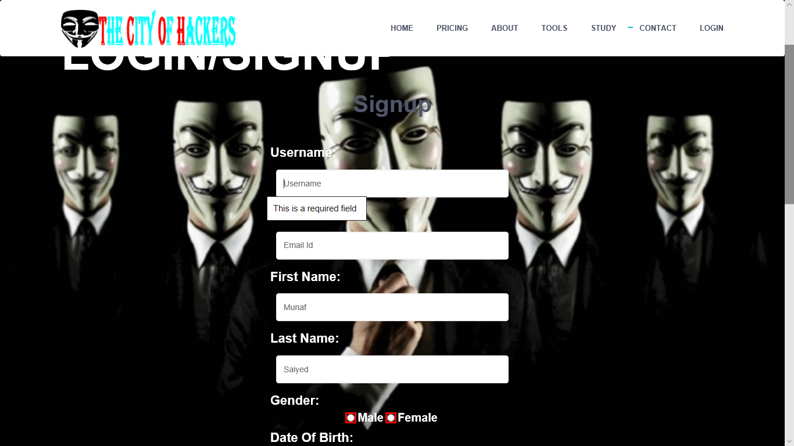

*Valid Email Validation:*

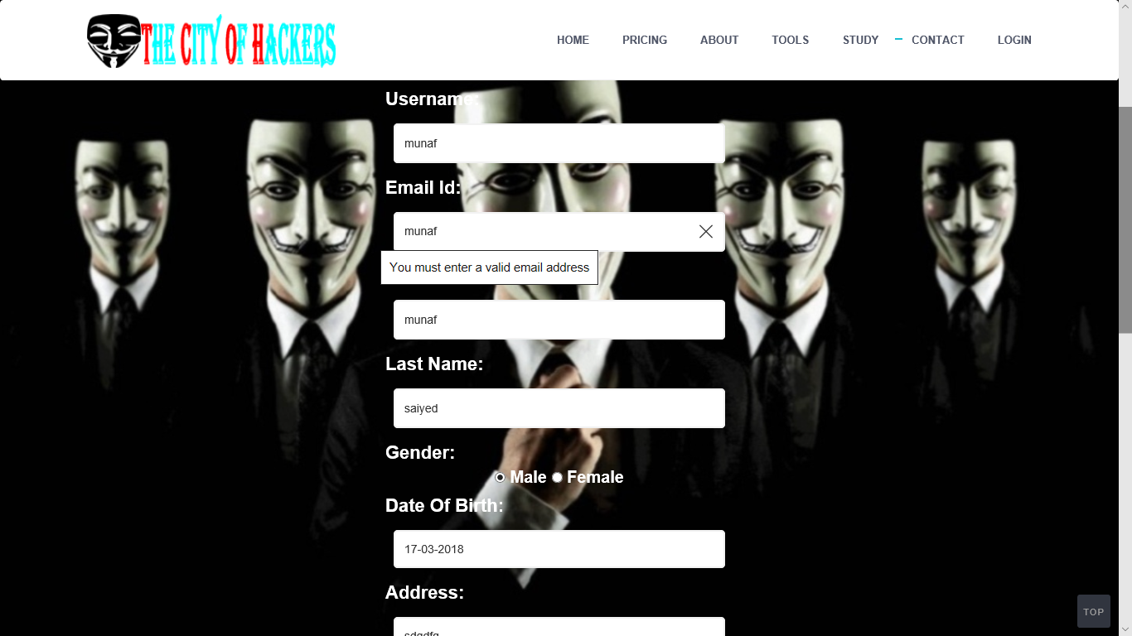

|  |
| --- |
|  |
|  |
|  |

Registration Page (User/Hacker)

*Valid Number Validation:*

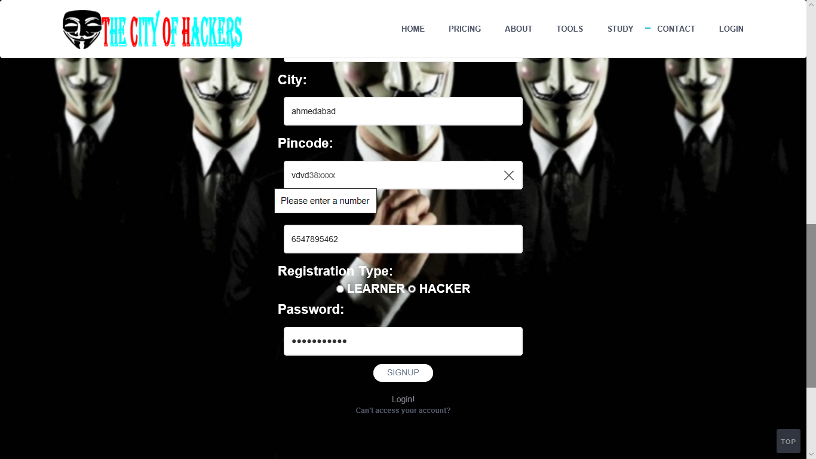

*Valid Date Validation:*

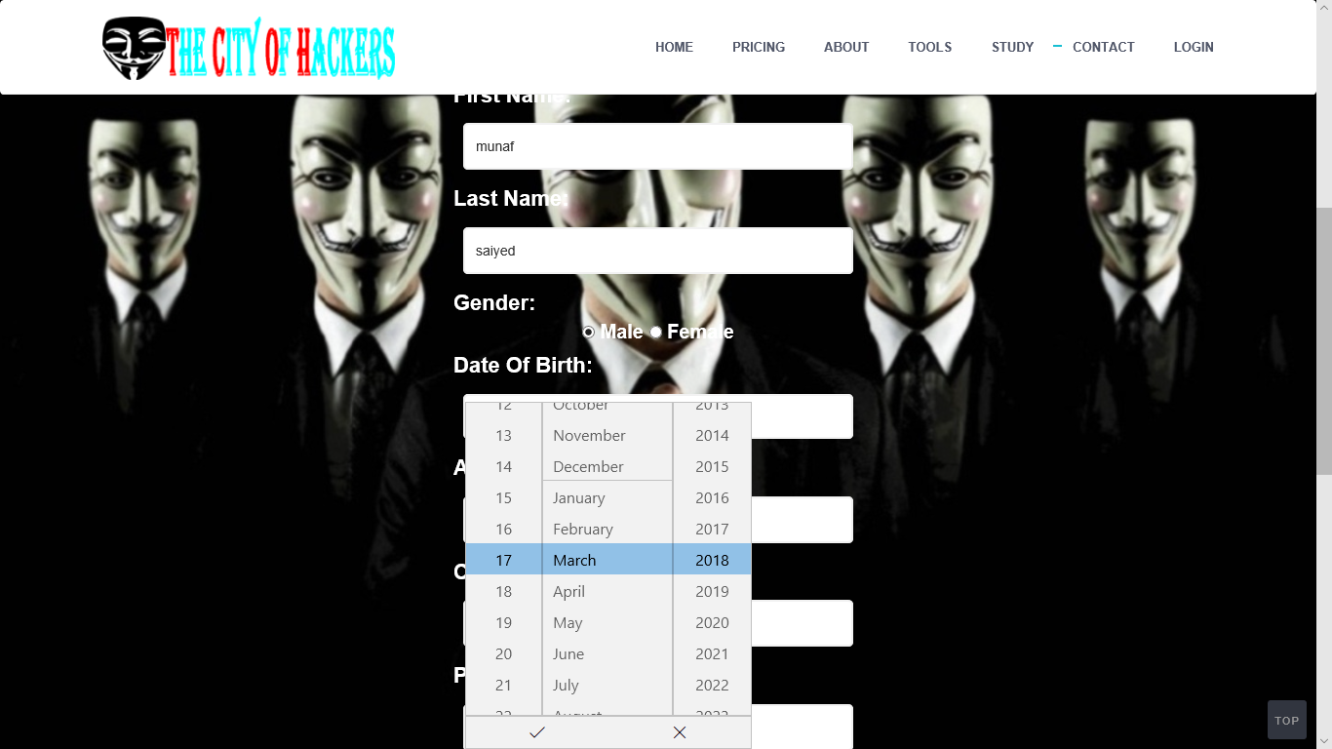

|  |
| --- |
|  |
|  |
|  |

After Login Effect(User/Hacker)

*Profile Chip:*



***Password Changing:***

*Not Empty Field Validation:*

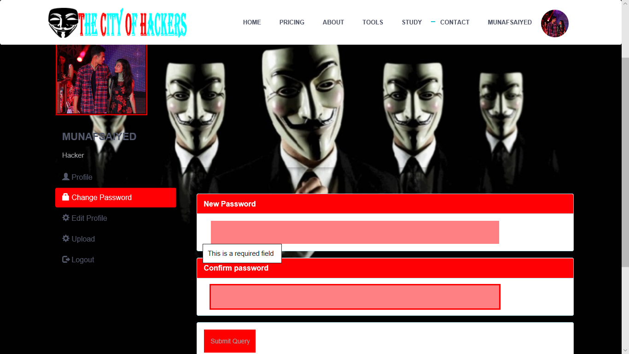

|  |
| --- |
|  |
|  |
|  |

After Login Effect(User/Hacker)

|  |
| --- |
|  |
|  |
|  |

***Password Changing:***

*Confirm password not matched validation:*

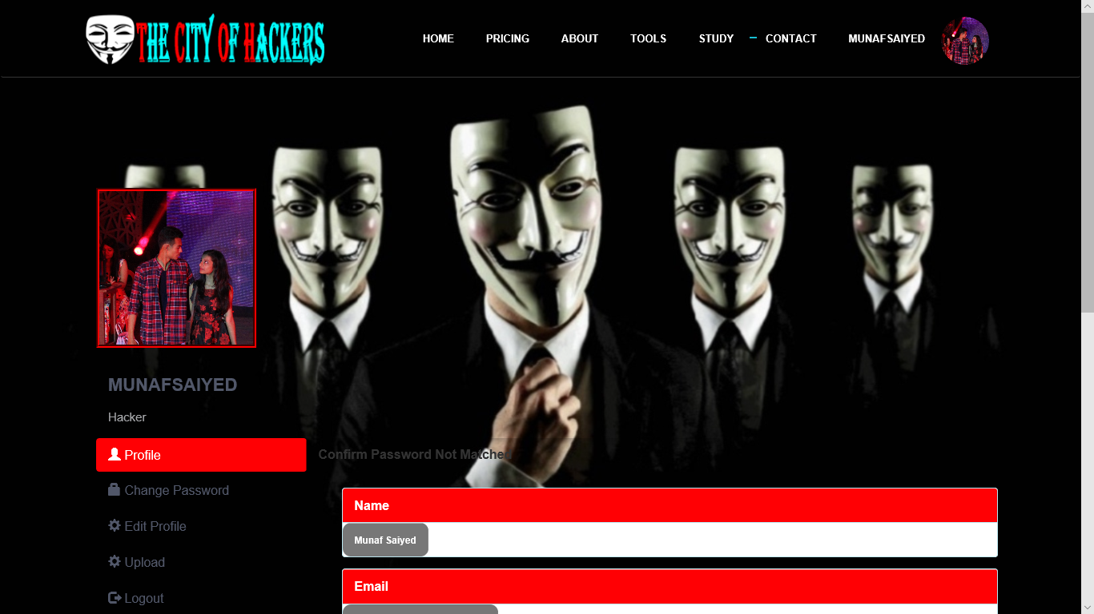

***Edit Profile:***

*Update Profile Data With profile pic Not Upload data error:*

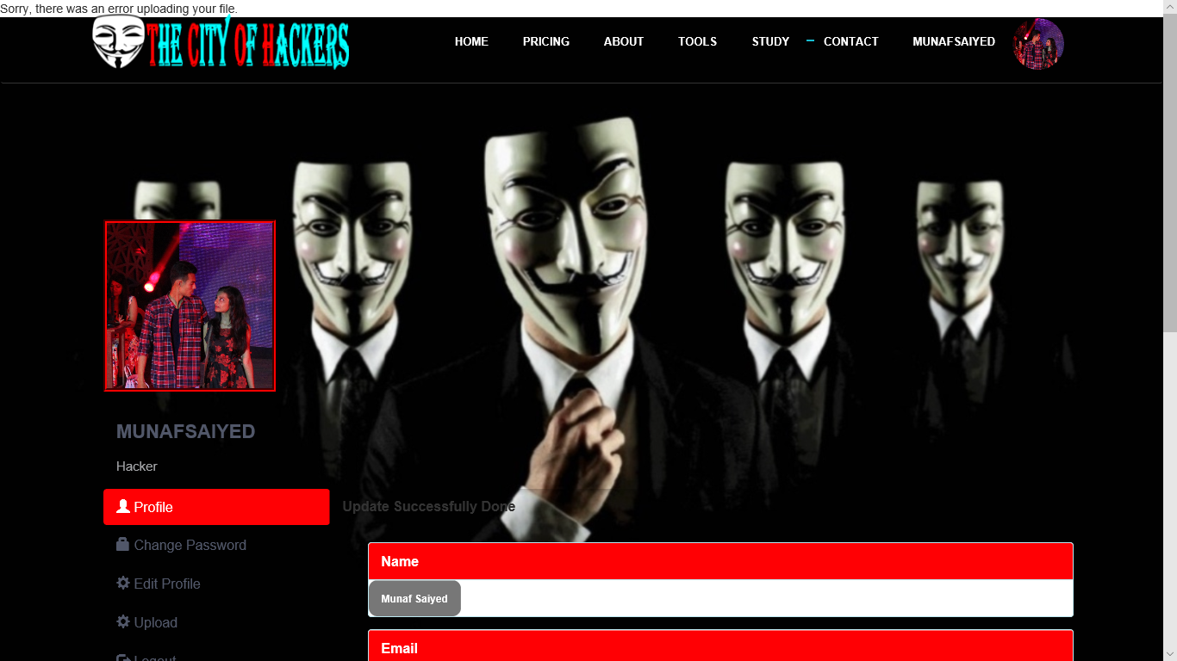

|  |
| --- |
|  |
|  |
|  |

After Login Effect(User/Hacker)

|  |
| --- |
|  |
|  |
|  |

***Edit Profile:***

*Uploading Profile Pic:*

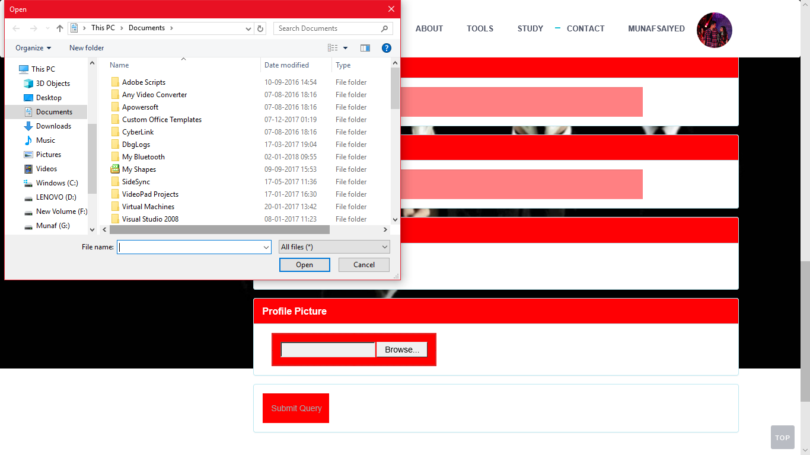

***Course Upload:***

*Uploading Empty File Validation:*

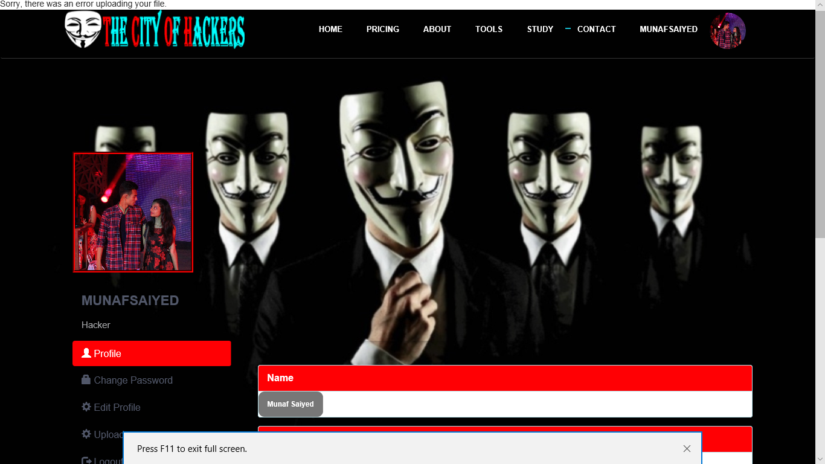

|  |
| --- |
|  |
|  |
|  |

After Login Effect(User/Hacker)

|  |
| --- |
|  |
|  |
|  |

***Course Upload:***

*Successfully Course Upload:*

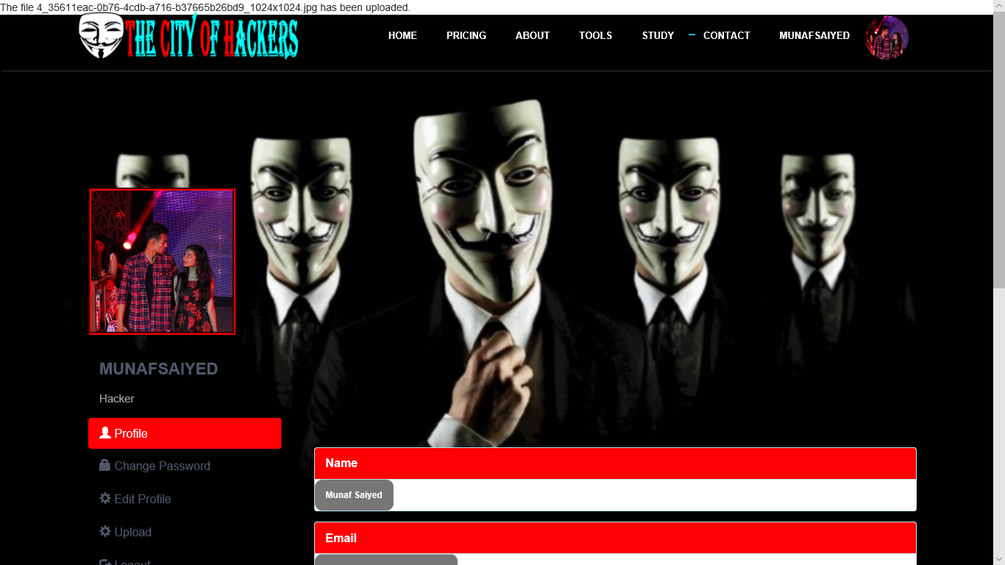

|  |
| --- |
|  |
|  |
|  |

After Login Effect(Admin Panel)

***Profile Update And View:***

*Showing profile details from database:*

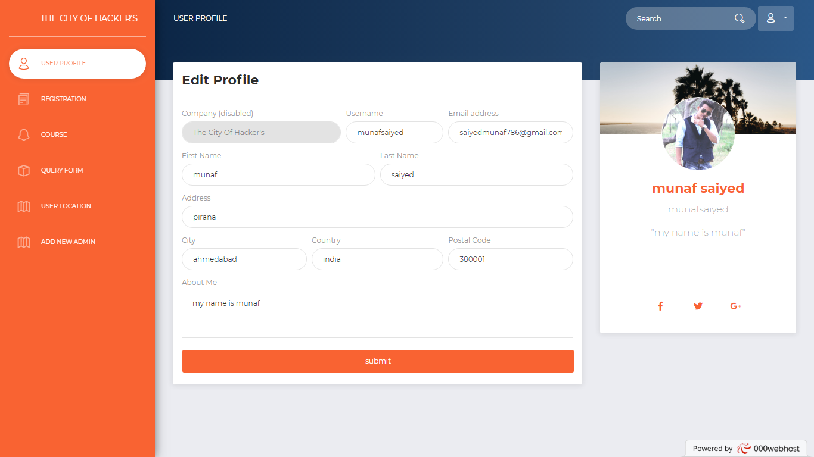

*Registration Details Report:*

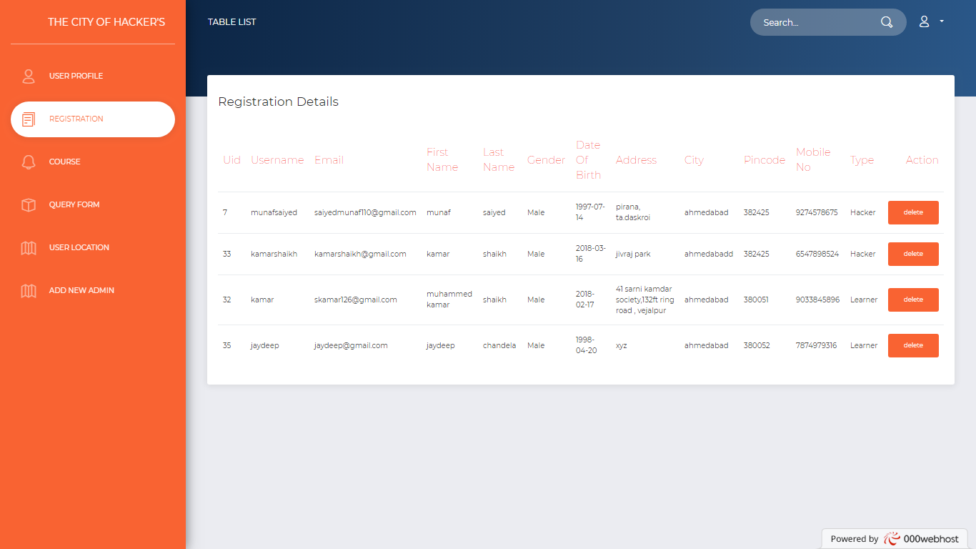

|  |
| --- |
|  |
|  |
|  |

After Login Effect(Admin Panel)

*Course Uploaded Report:*



*Query Form Uploaded Report:*



|  |
| --- |
|  |
|  |
|  |

After Login Effect(Admin Panel)

*Take Location Of Users Report:*

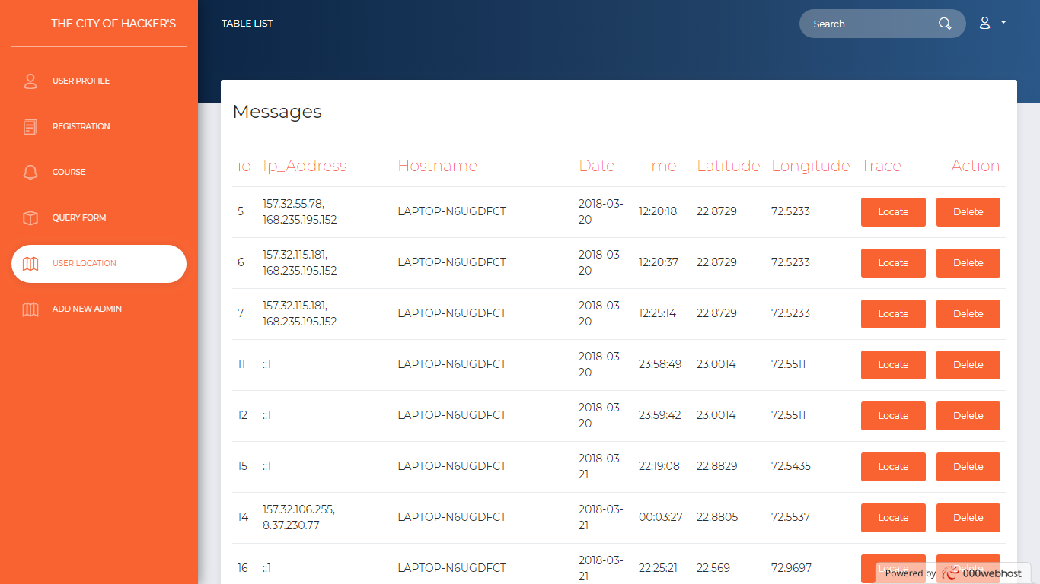

*Tracking Location Of Users:*

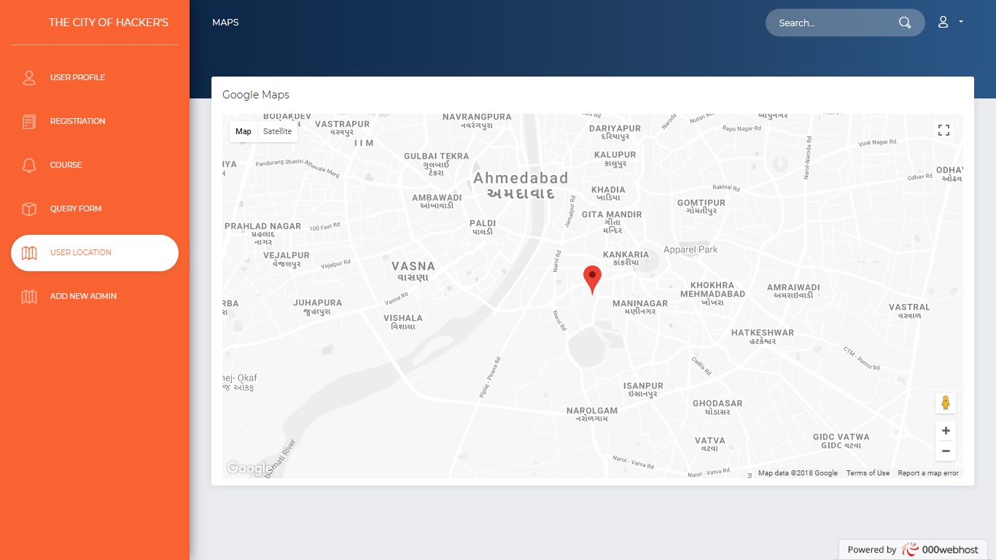

|  |
| --- |
|  |
|  |
|  |

After Login Effect(Admin Panel)

*Register New Admin Its Done By Only Main Admin:*

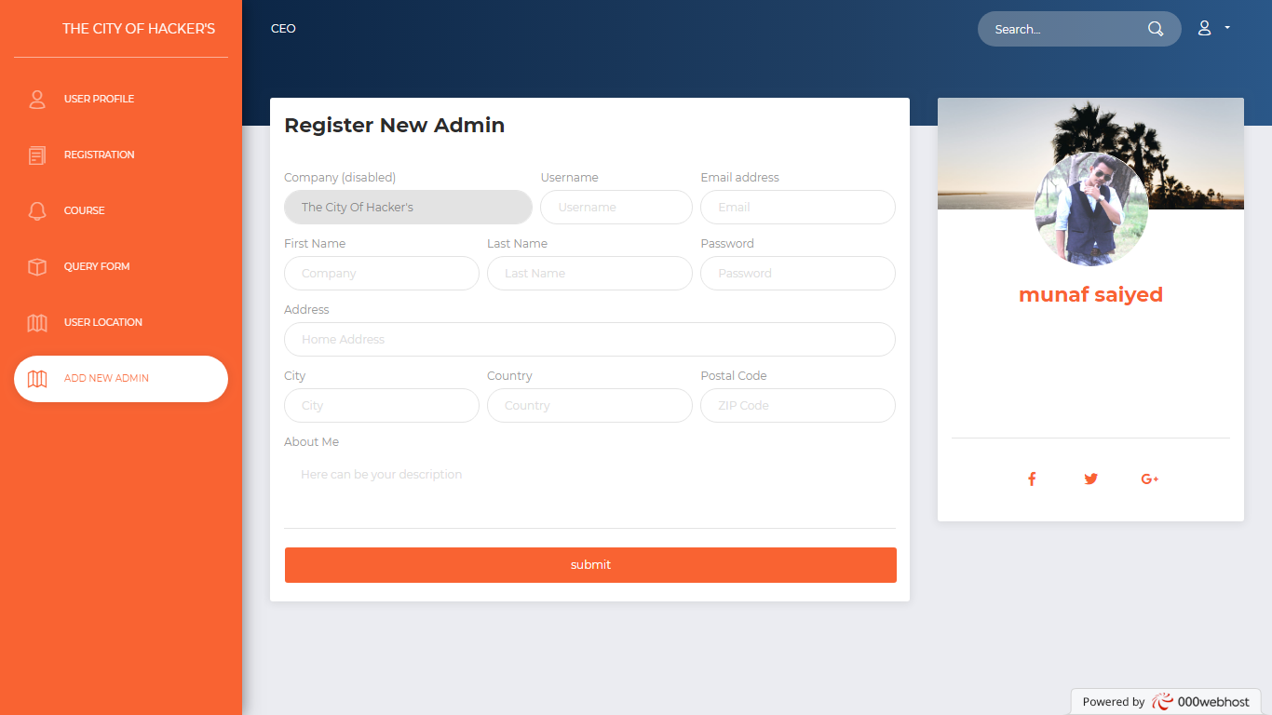

|  |
| --- |
|  |
|  |
|  |

Data Dictionary

***adminmaster:***

|  |  |  |  |  |
| --- | --- | --- | --- | --- |
| Sr no. | Field Name | Data Type | Size | Constarints |
| 1 | idn | int | 11 | Primary Key,  Auto_Increment, Not Null |
| 2 | username | text | - | Not Null |
| 3 | email | text | - | Not Null |
| 4 | f_name | varchar | 50 | Not Null |
| 5 | l_name | varchar | 50 | Not Null |
| 6 | addresh | longtext | - | Not Null |
| 7 | city | varchar | 50 | Not Null |
| 8 | country | varchar | 50 | Not Null |
| 9 | pincode | int | 10 | Not Null |
| 10 | about | longtext | - | Not Null |
| 11 | password | varchar | 20 | Not Null |

|  |
| --- |
|  |
|  |
|  |

Data Dictionary

***Course:***

|  |  |  |  |  |
| --- | --- | --- | --- | --- |
| Sr no. | Field Name | Data Type | Size | Constarints |
| 1 | cid | int | 11 | Primarykey, Auto increment, not null |
| 2 | username | varchar | 50 | Not null |
| 3 | file_name | varchar | 50 | Not null |
| 4 | article | longtext | - | Not null |

|  |
| --- |
|  |
|  |
|  |

Data Dictionary

***Query_form:***

|  |  |  |  |  |
| --- | --- | --- | --- | --- |
| Sr no. | Field name | Data type | Size | Constraints |
| 1 | q_id | int | 11 | Primarykey, auto increment, not null |
| 2 | name | varchar | 30 | Not null |
| 3 | email | varchar | 40 | Not null |
| 4 | phone | int | 12 | Not null |
| 5 | message | longtext | - | Not null |

|  |
| --- |
|  |
|  |
|  |

Data Dictionary

***registration:***

|  |  |  |  |  |
| --- | --- | --- | --- | --- |
| Sr no. | Field name | Data type | Size | Constrains |
| 1 | uid | int | 10 | Primarykey, auto increment, not null |
| 2 | username | varchar | 20 | Not null, Unique |
| 3 | email | varchar | 30 | Not null |
| 4 | f_name | text | - | Not null |
| 5 | l_name | text | - | Not null |
| 6 | gender | varchar | 10 | Not null |
| 7 | dob | varchar | 20 | Not null |
| 8 | address | varchar | 50 | Not null |
| 9 | city | text | - | Not null |
| 10 | pincode | int | 7 | Not null |
| 11 | m_no | bigint | 13 | Not null |
| 12 | type | text | - | Not null |
| 13 | password | varchar | 15 | Not null |

|  |
| --- |
|  |
|  |
|  |

Data Dictionary

***trackingg:***

|  |  |  |  |  |
| --- | --- | --- | --- | --- |
| Sr no. | Field name | Data type | Size | constrains |
| 1 | id | int | 11 | Primarykey, auto increment, not null |
| 2 | ip | longtext | - | Not null |
| 3 | hostname | varchar | 50 | Not null |
| 4 | date | date | - | Not null |
| 5 | time | time | - | Not null |
| 6 | lat | float | - | Not null |
| 7 | lon | float | - | Not null |

|  |
| --- |
|  |
|  |
|  |

Conclusion

* E-learning brings with it new dimensions in education many of the unique features of e-learning this project have a smart way to learning courses the user feel friendly environment anywhere and anytime.
* 24/7 accesibility makes scheduling easy and allows a greater number of people to attend classes.

|  |
| --- |
|  |
|  |
|  |

Bibliography

These are the following links which assist me at each and every step in completing this project, without them I was not being able to finish this importance project:

1. [www.google.com](http://www.google.com/)

2. [www.youtube.com](http://www.youtube.com)

3. [www.cybrary.com](http://www.cybrary.com)

4. [www.hacking-lab.com](http://www.hacking-lab.com)